**Jenkins-04**

**Title: 1. Setup Jenkins CICD pipeline using freestyle job using Docker containers using below code.**[**https://github.com/betawins/hiring-app.git**](https://github.com/betawins/hiring-app.git)

**Stages:**Git Clone  
SonarQube Integration  
Maven Compilation  
Nexus Artifactory  
Slack Notification  
Deploy On tomcat

**objective:** To design and implement an end-to-end CI/CD pipeline using Jenkins Freestyle Job.

* To automate the complete application lifecycle starting from source code retrieval to deployment on Apache Tomcat.
* To integrate code quality checks, artifact management, notifications, and automated deployment.
* To ensure faster, reliable, and repeatable application delivery using DevOps best practices.

**prerequisite**:

Jenkins server

SonarQube server

nexus server

tomcat server

installed java in all servers

docker installed running in SonarQube server

git installed and running in Jenkins master server

Nexus Repository Manager running and accessible

GitHub repository URL:

<https://github.com/betawins/hiring-app.git>

**step by step process:**

**Git clone:**

**installing Jenkins in master server and run….**

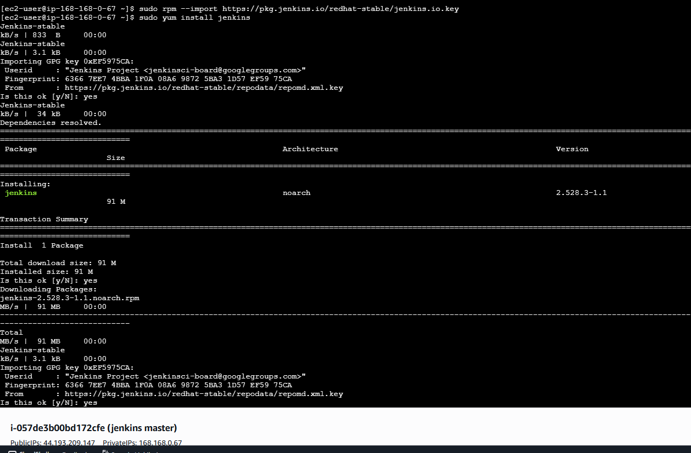

installed git and run….

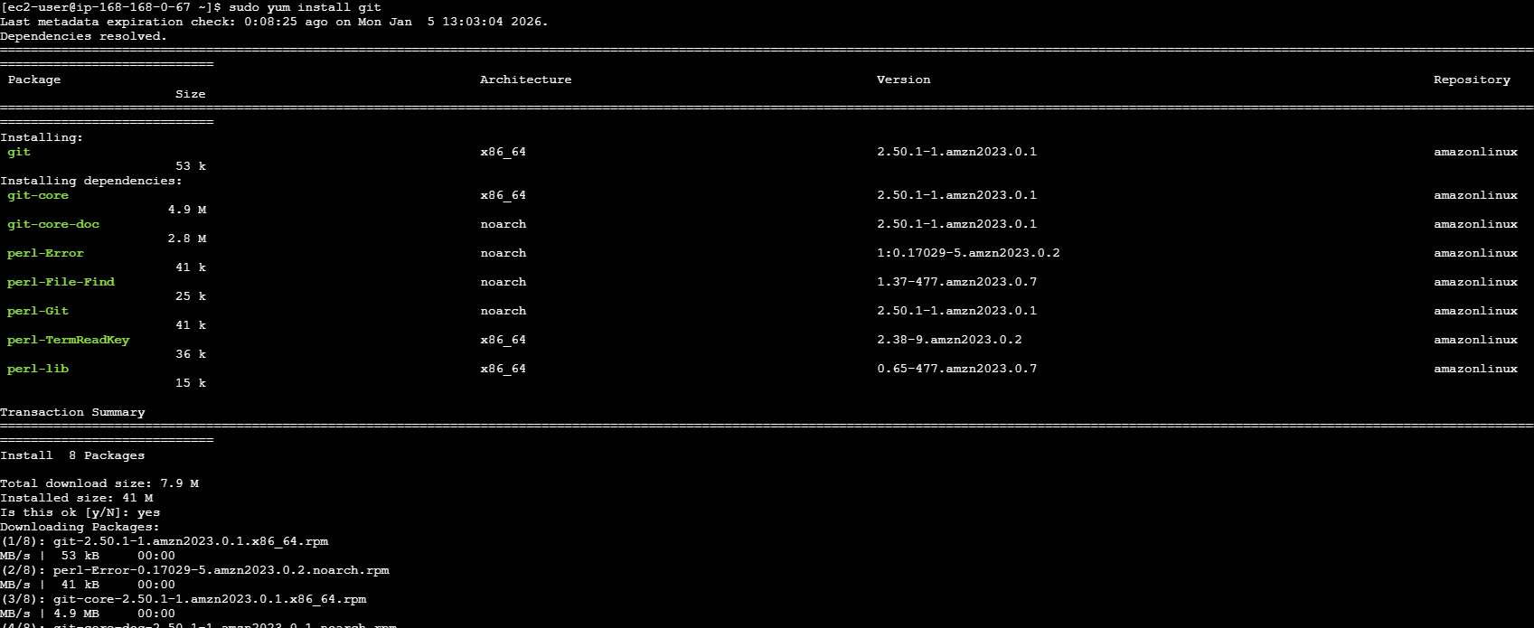

and start the Jenkins service

now we need to login Jenkins----new item---creating job---free style project---configure---add the repository URL in source code management---and click on save

job has been created

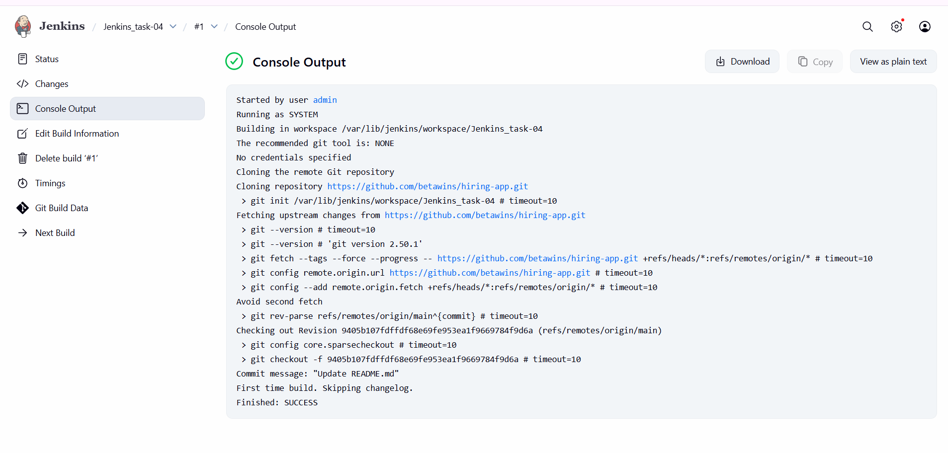

**SonarQube Integration**

install docker and run in SonarQube server and run...

sudo yum install docker -y

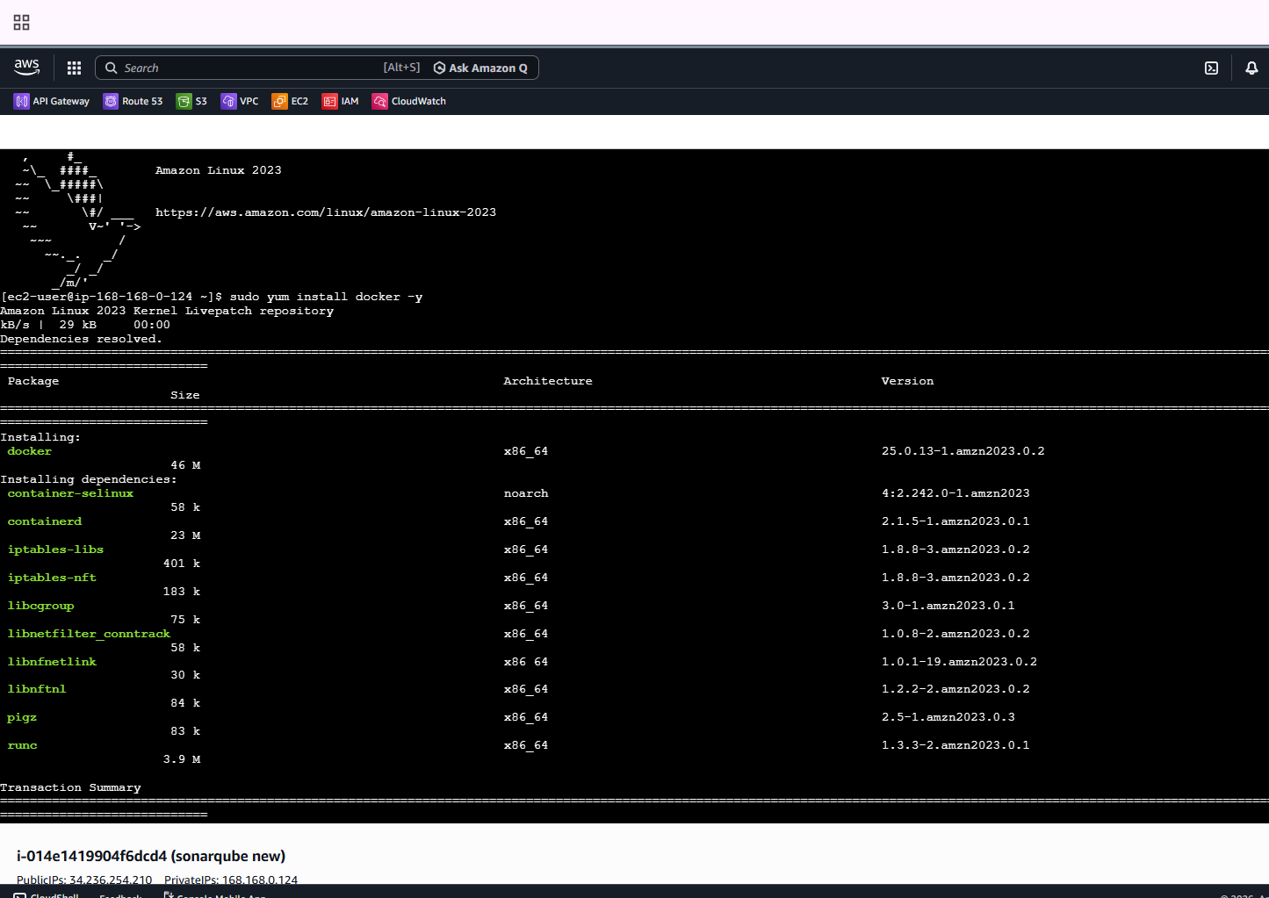

enable SonarQube

docker run -d –name SonarQube-server -p 9003:9000 SonarQube

docker ps

docker pull SonarQube

systemctl status docker

docker start sonarqube-server

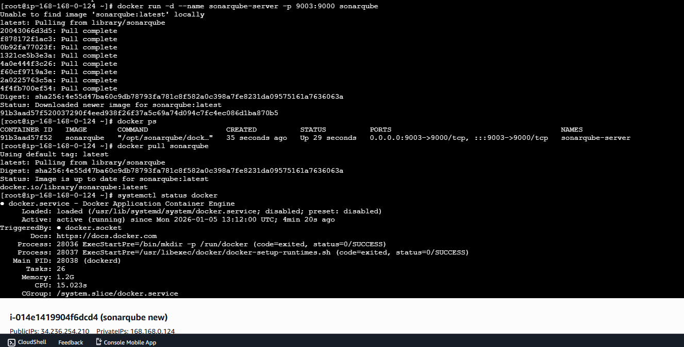

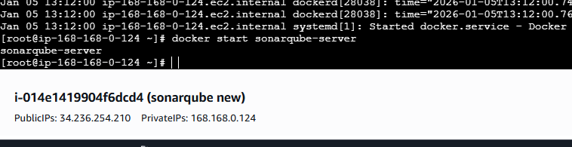

Jenkins---manage Jenkins---system—SonarQube installations—add name and urn of your SonarQube and save it

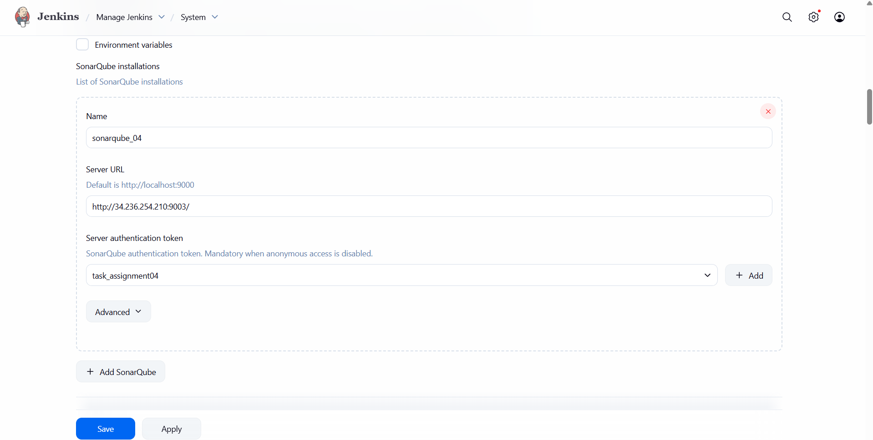

after logging in browser---create token and copy the token and add in credentials

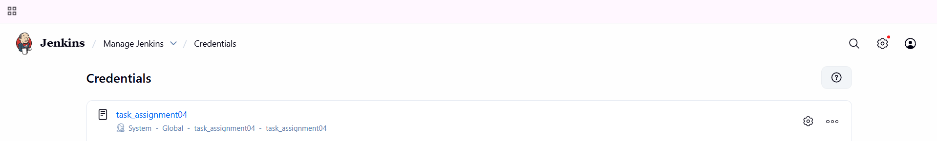

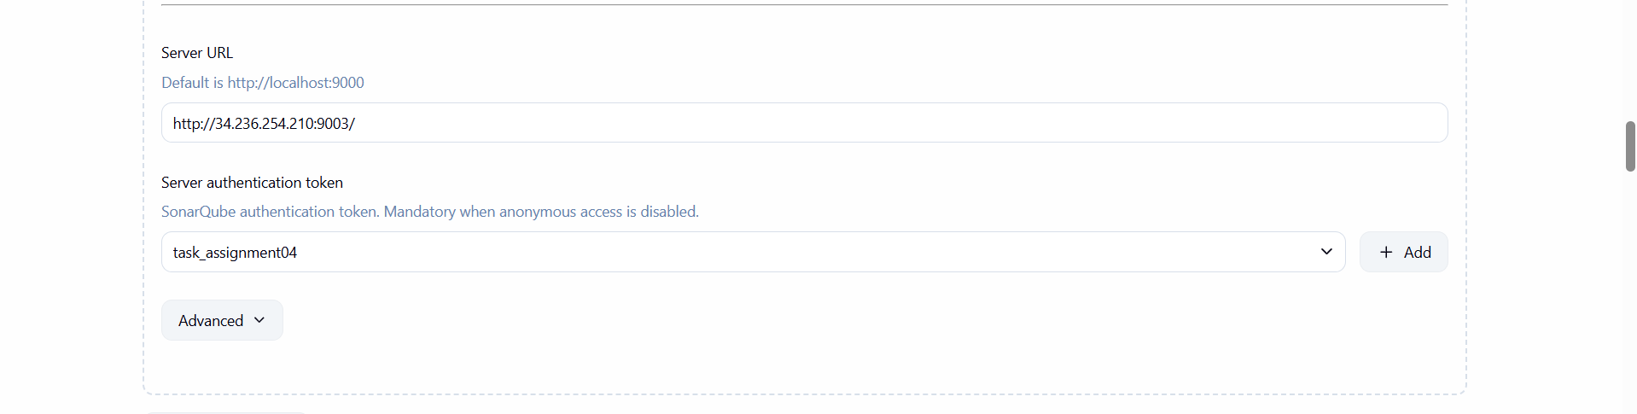

now install sonar scanner in Jenkins master server and download sonar scanner plugin in Jenkins

cd /opt

wget <https://binaries.sonarsource.com/Distribution/sonar-scanner-cli/sonar-scanner-cli-5.0.1.3006-linux.zip>

unzio sonar-scanner

ls

mv sonar-scanner-5.0.1.3006-linux sonar-scanner

cd sonar-scanner/

ls

cd bin/

pwd

opt/sonar-scanner/bin

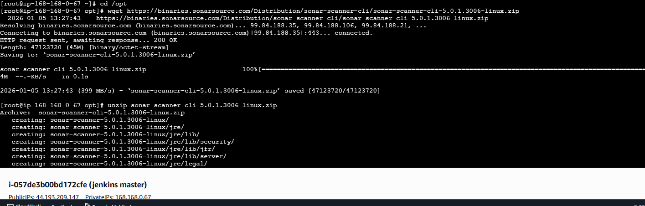

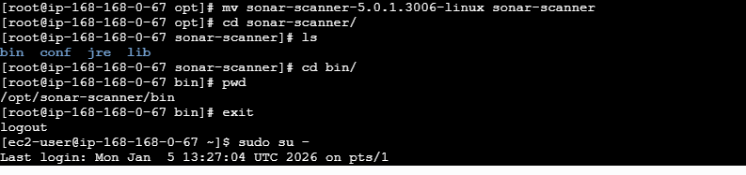

copy the path----manage Jenkins---tools—name—add the URL and save it

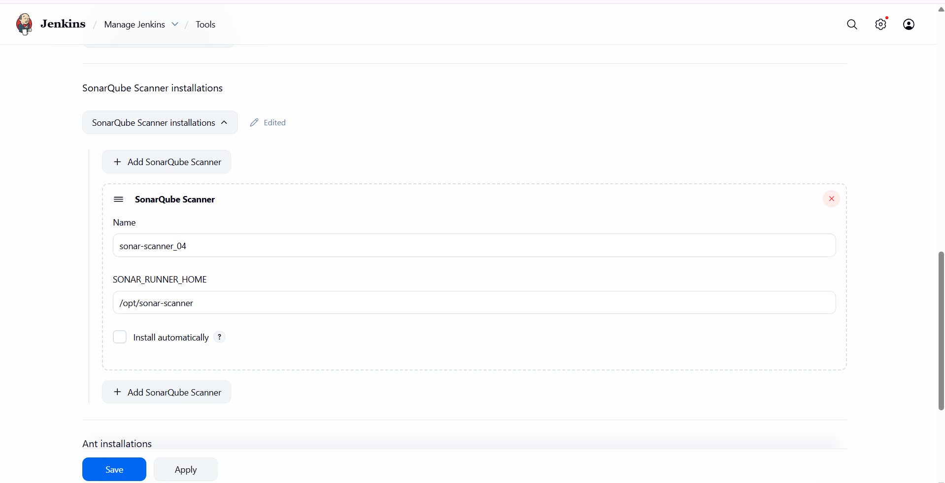

go to configure and add the analysis properties…

sonar.projectKey=Sabear

sonar.projectName=Sabear

sonar.projectVersion=1.0

sonar.sources=/var/lib/jenkins/workspace/$JOB_NAME/src/

sonar.binaries=target/classes/com/visualpathit/account/controller/

sonar.junit.reportsPath=target/surefire-reports

sonar.jacoco.reportPath=target/jacoco.exec

sonar.java.binaries=src/main/java/com/visualpathit/account/

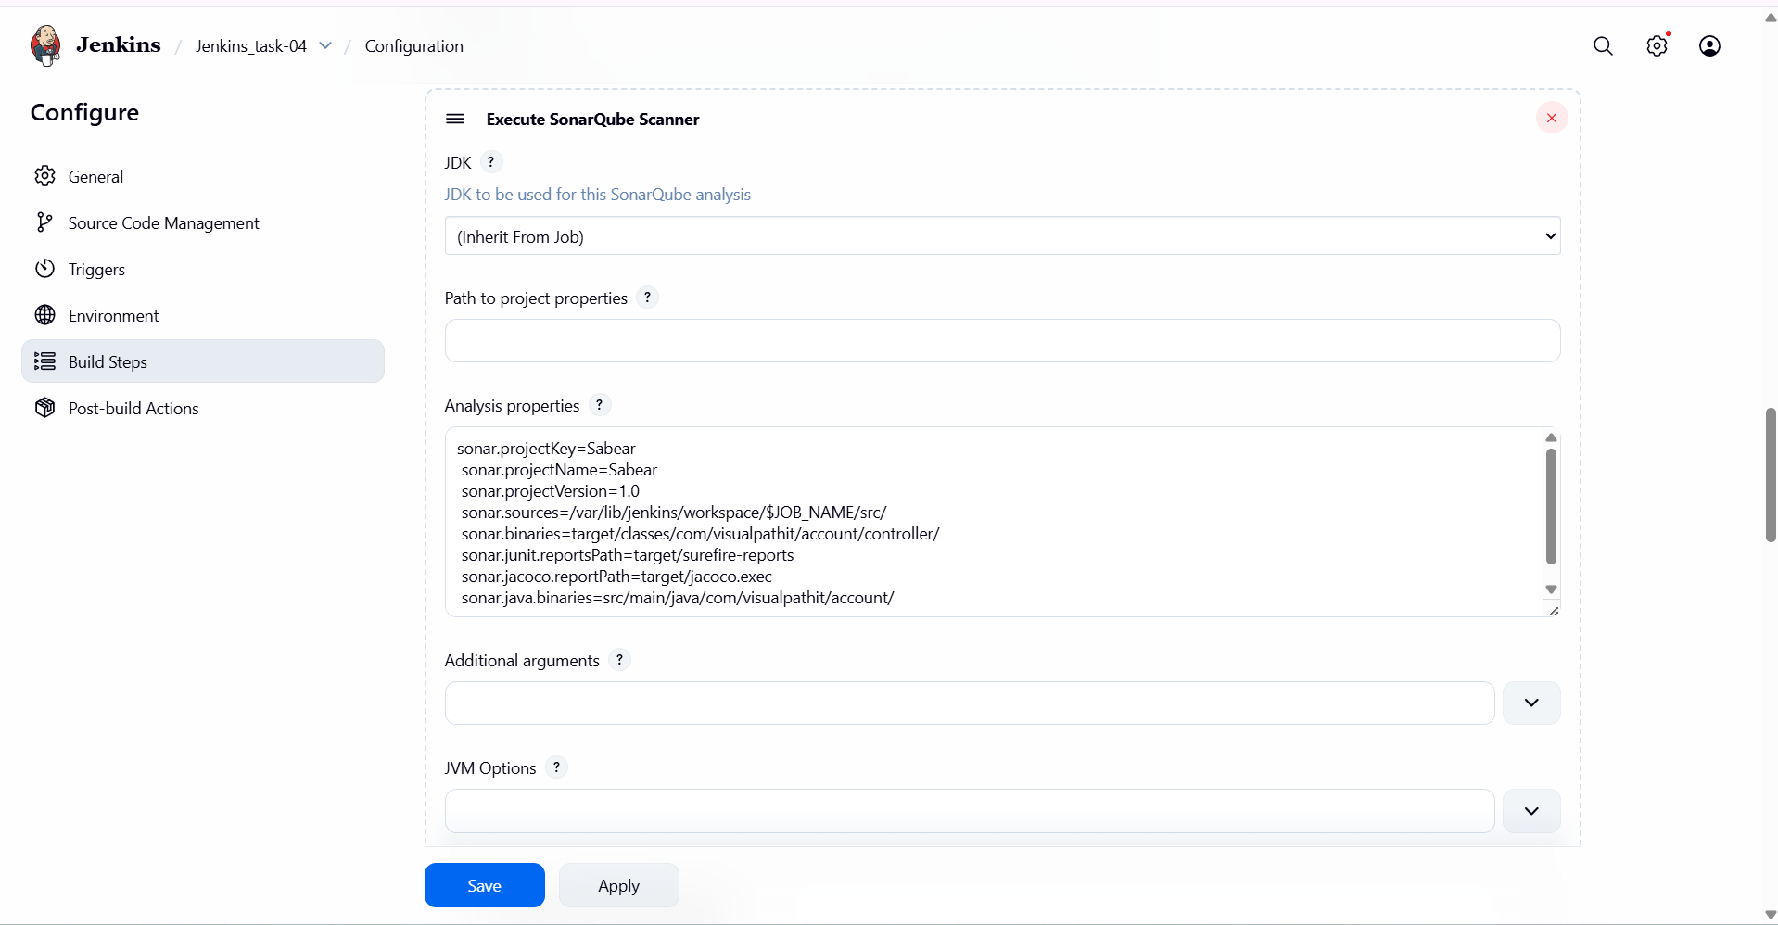

click on build now…

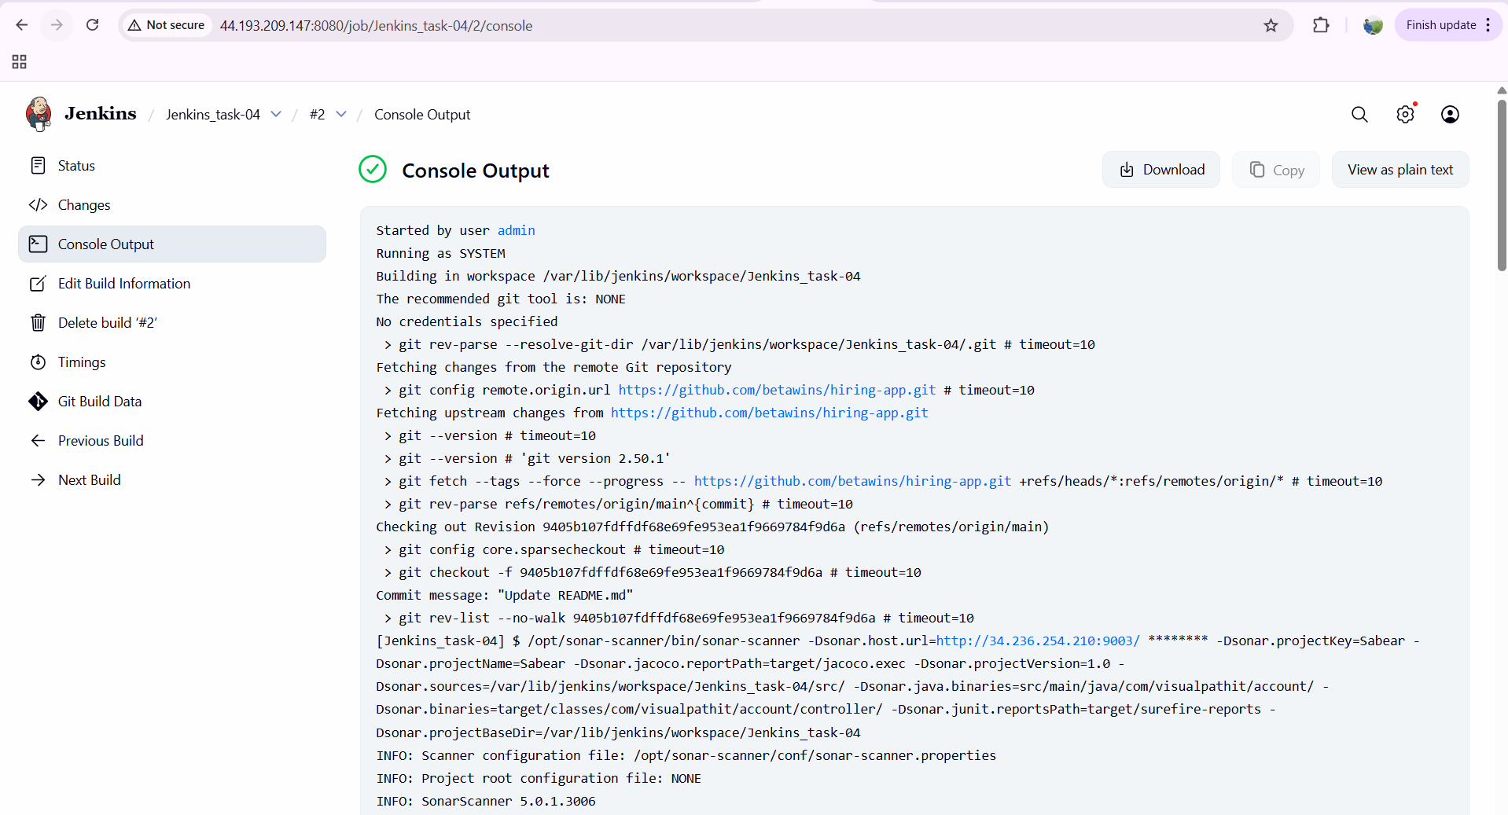

**verify in browser now**

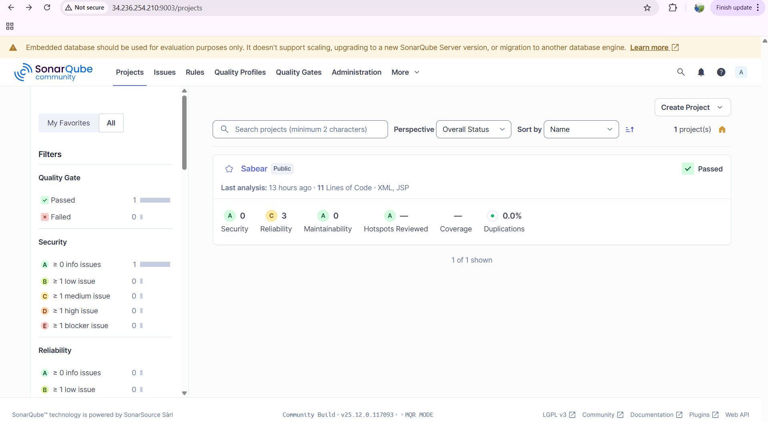

**Maven Compilation**

install maven in Jenkins master server

go to your browser---search for maven download---select the version of maven 3.9.12 and copy the link

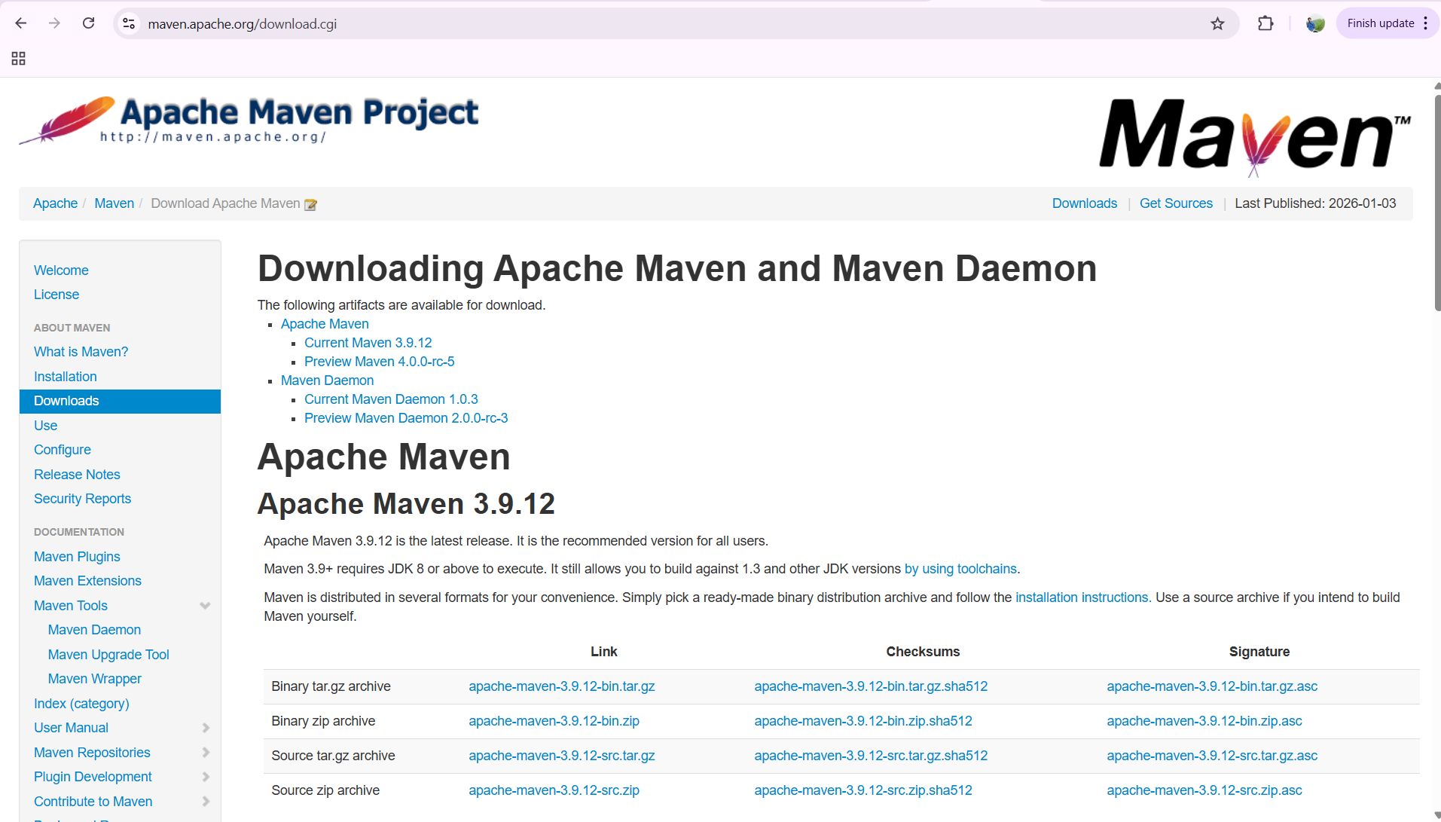

cd /opt

wget <https://dlcdn.apache.org/maven/maven-3/3.9.12/binaries/apache-maven-3.9.12-bin.tar.gz>

then extract it

tar xvf apache-maven-3.9.12-bin.tar.gz

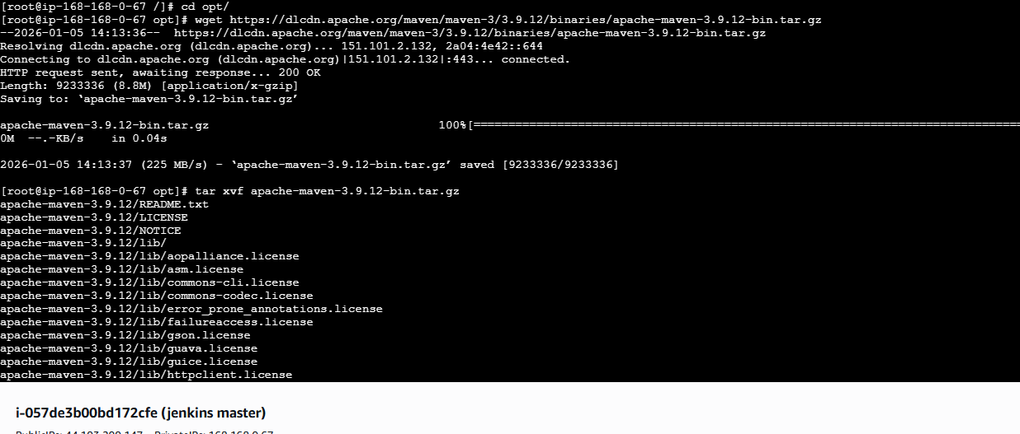

ls

mv apache-maven-3.9.12 maven

ls

cd maven/

ls

cd bin/

ls

pwd

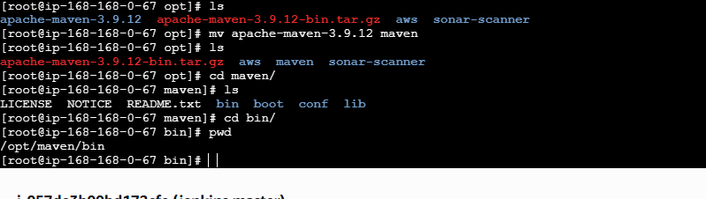

vi .bash_profile

export M2_home=/opt/maven

export PATH=$PATH:$HOME/bin:$M2_home/bin

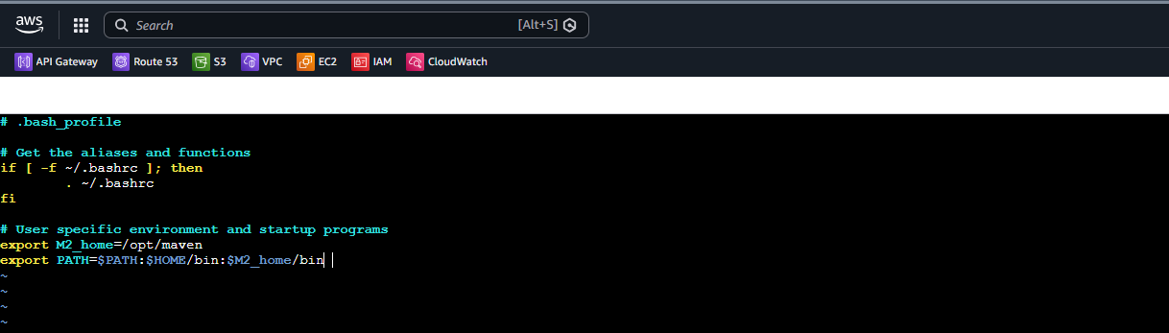

go to manage Jenkins---tools—maven installations—add maven—maven name MVN_HOME—copy and enter the path /opt/maven—click on save

now go to configuration---build steps—add build step---invoke top-level maven targets---enter maven version name—MVN_HOME—goals—clean install--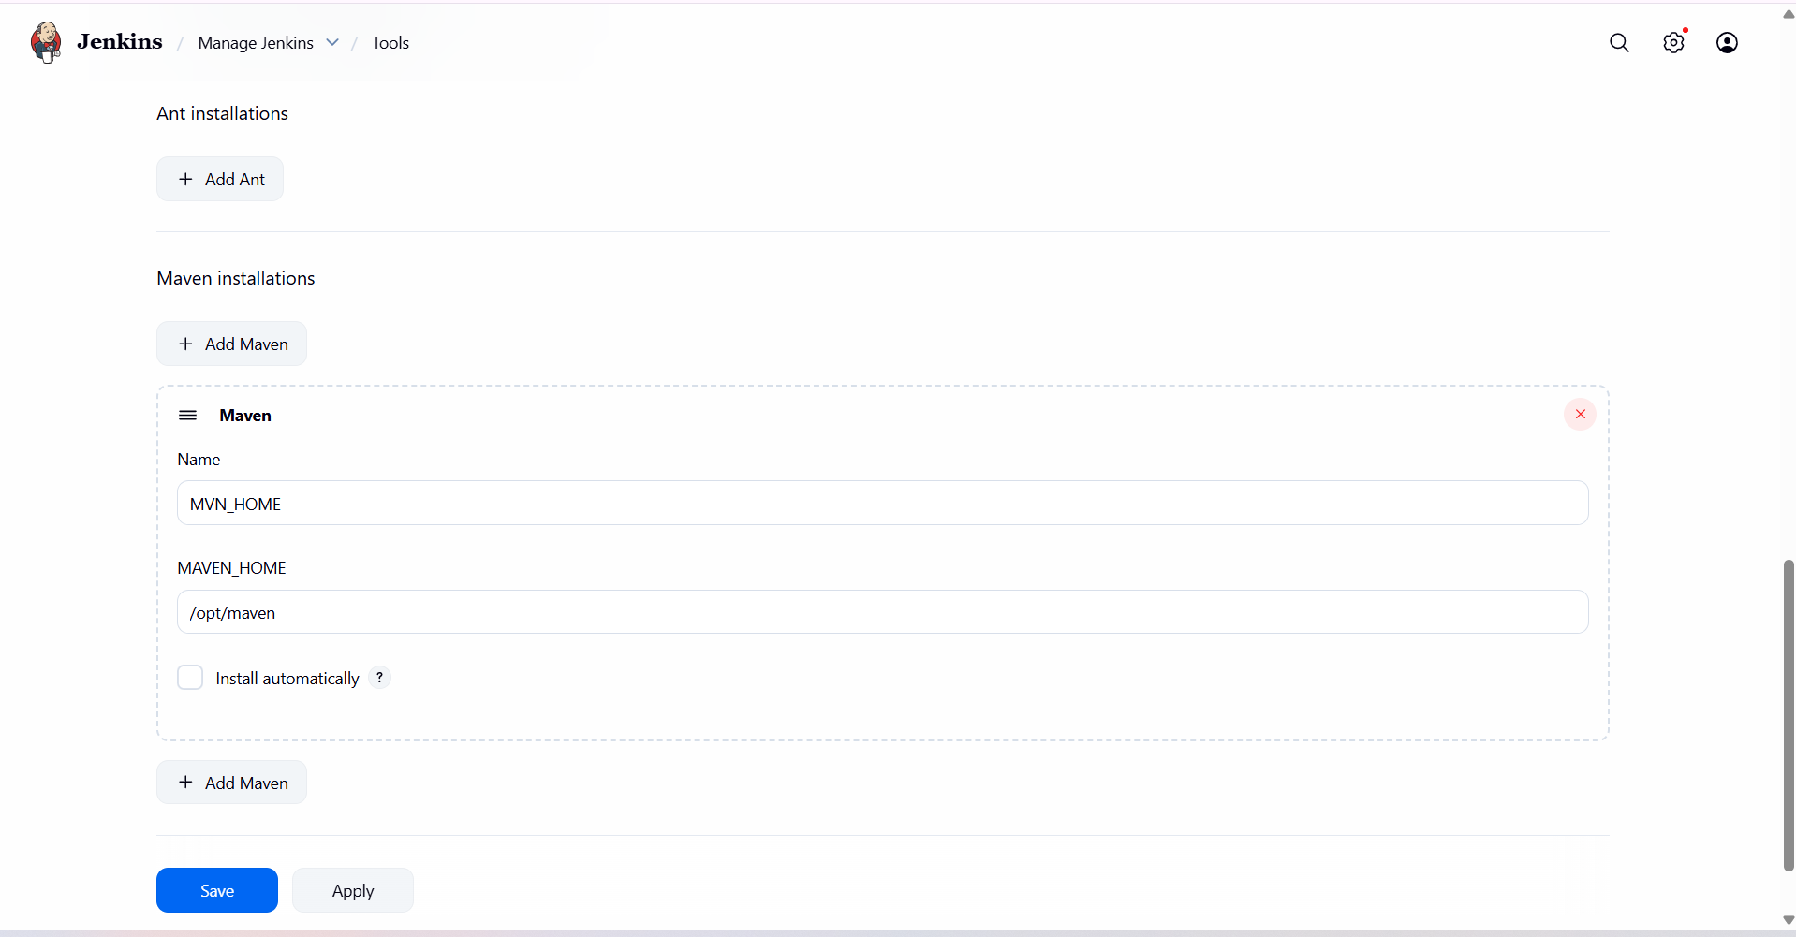save

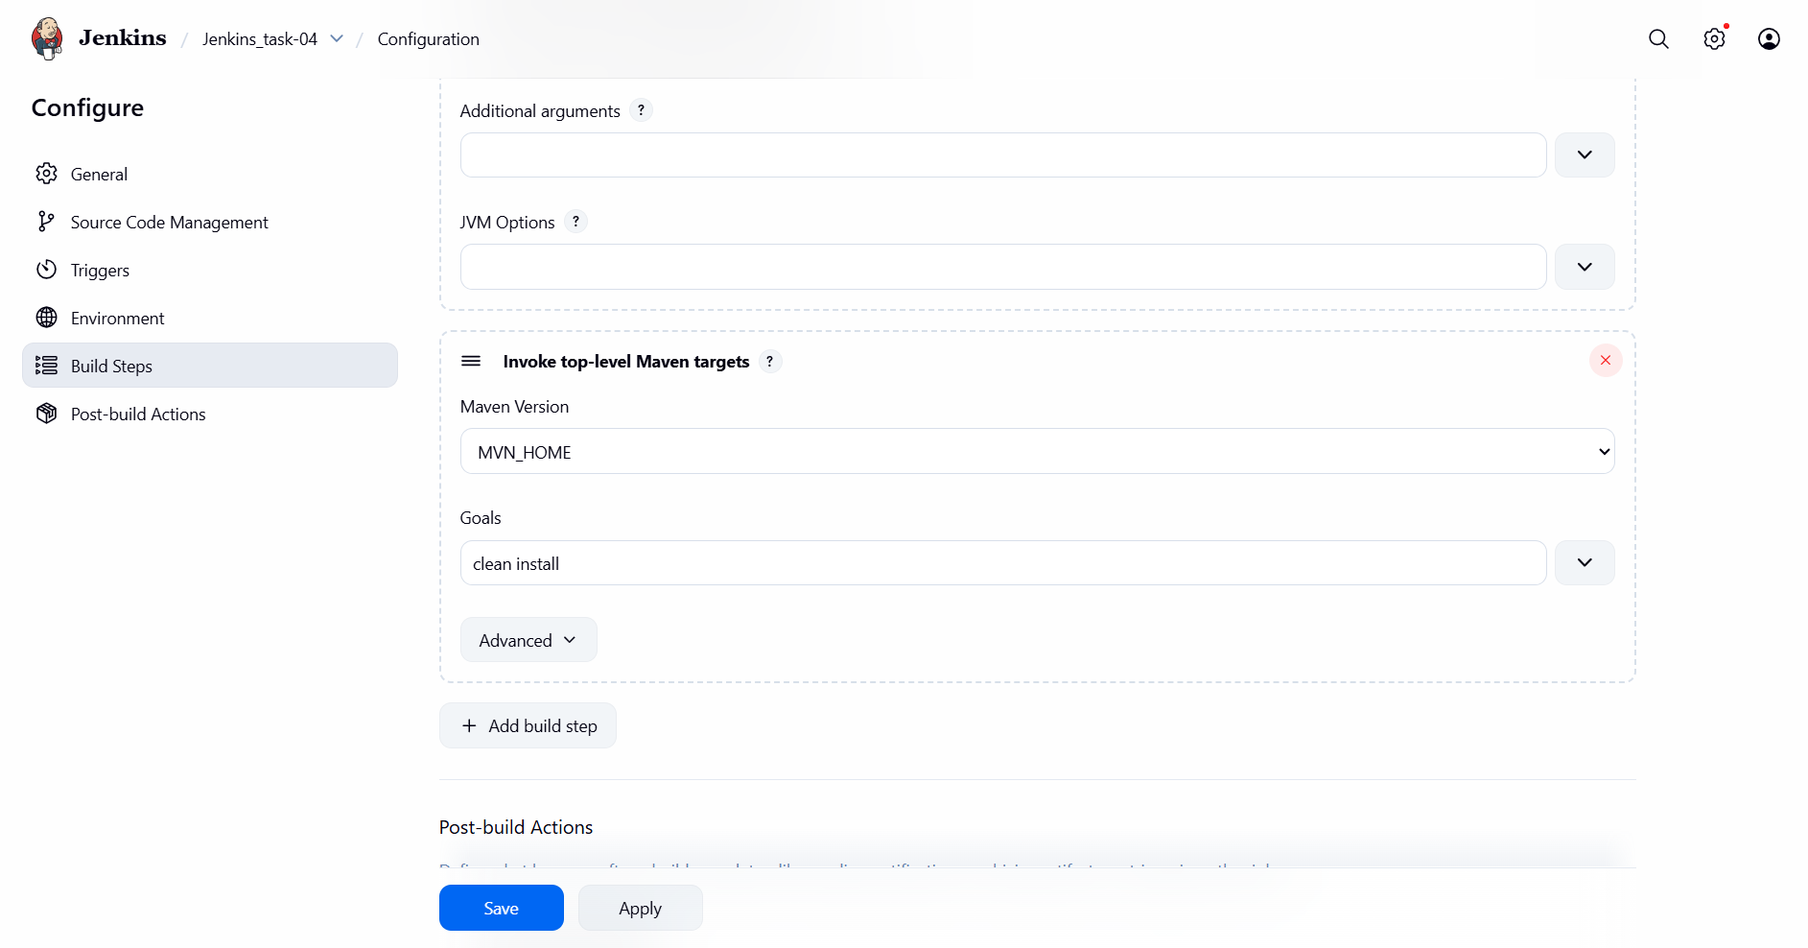

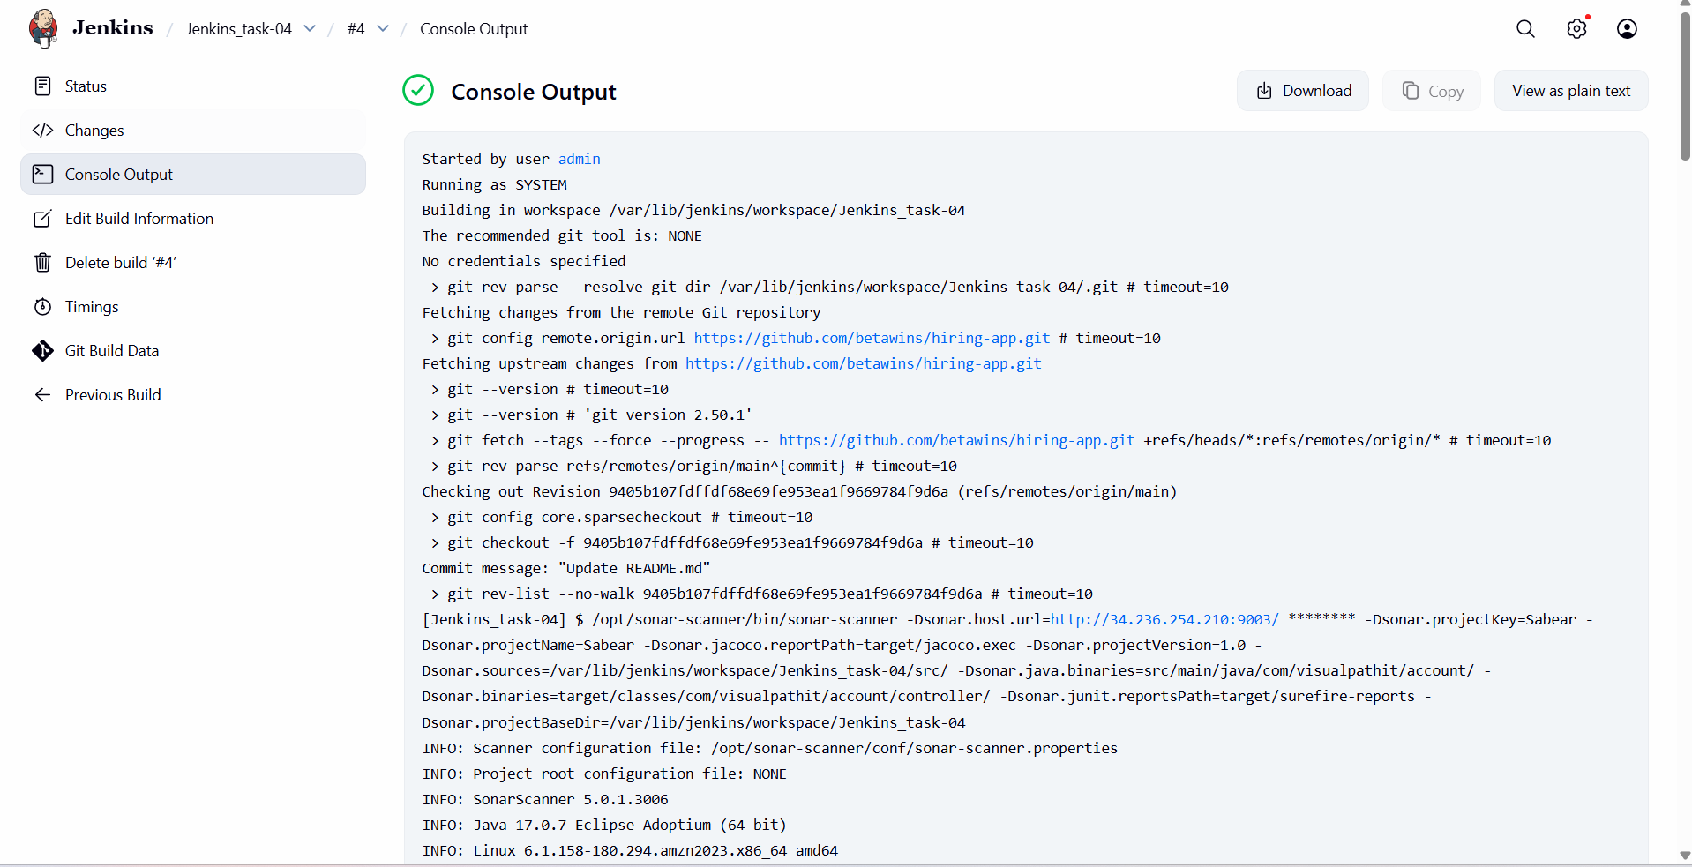

verify the all files has been configured or not

cd /var/lib/jenkins/.m2/reposotiry

ll

cd /var/lib/jenkins/workspace

ll

cd jenkins task-04/

ll

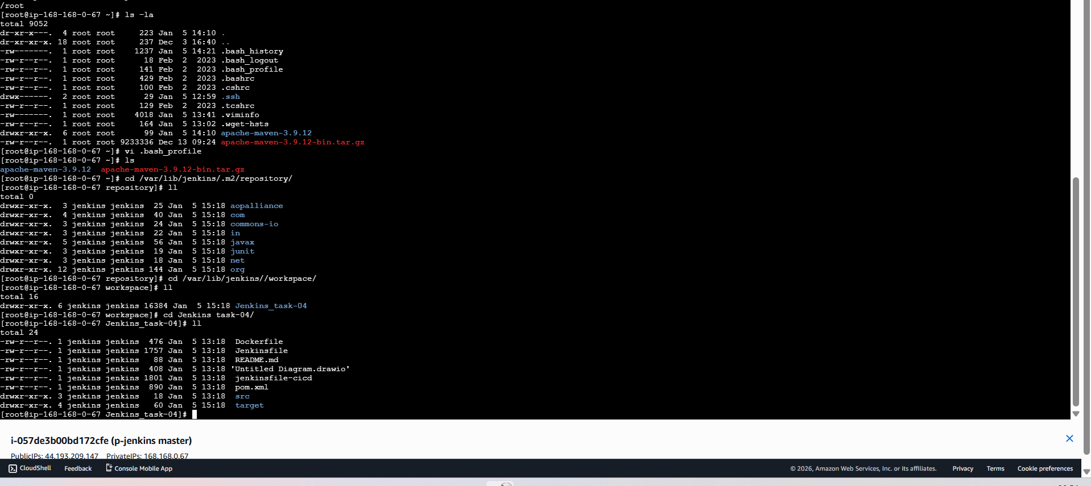

**Nexus Artifactory**

first launch one instance for installing nexus



connect now….

first install java in nexus server

sudo yum install java-17-amazon-corretto -y

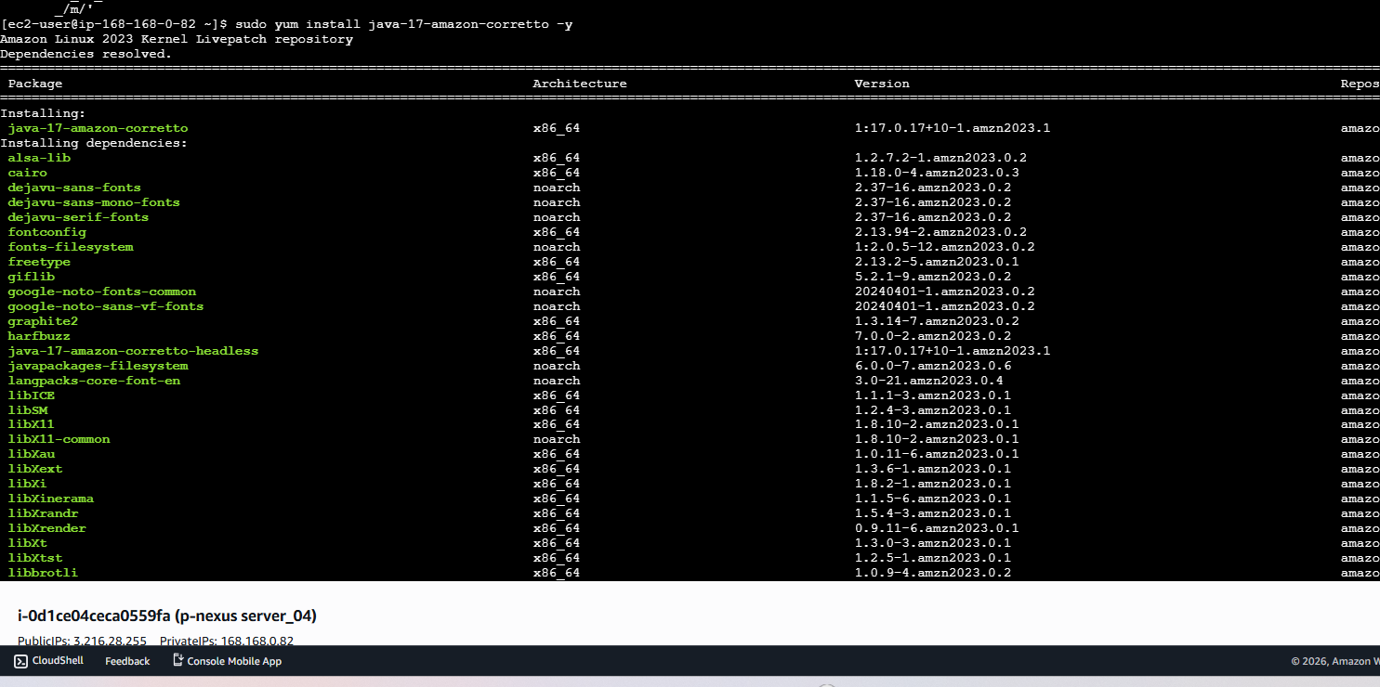

now go to browser and search for nexus download…copy the link

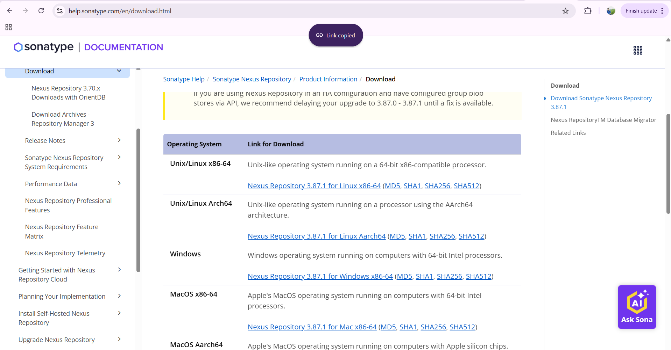

cd /opt

wget <https://download.sonatype.com/nexus/3/nexus-3.87.1-01-linux-x86_64.tar.gz>

then extract it

tar xvf nexus-3.87.1-01-linux-x86_64.tar.gz

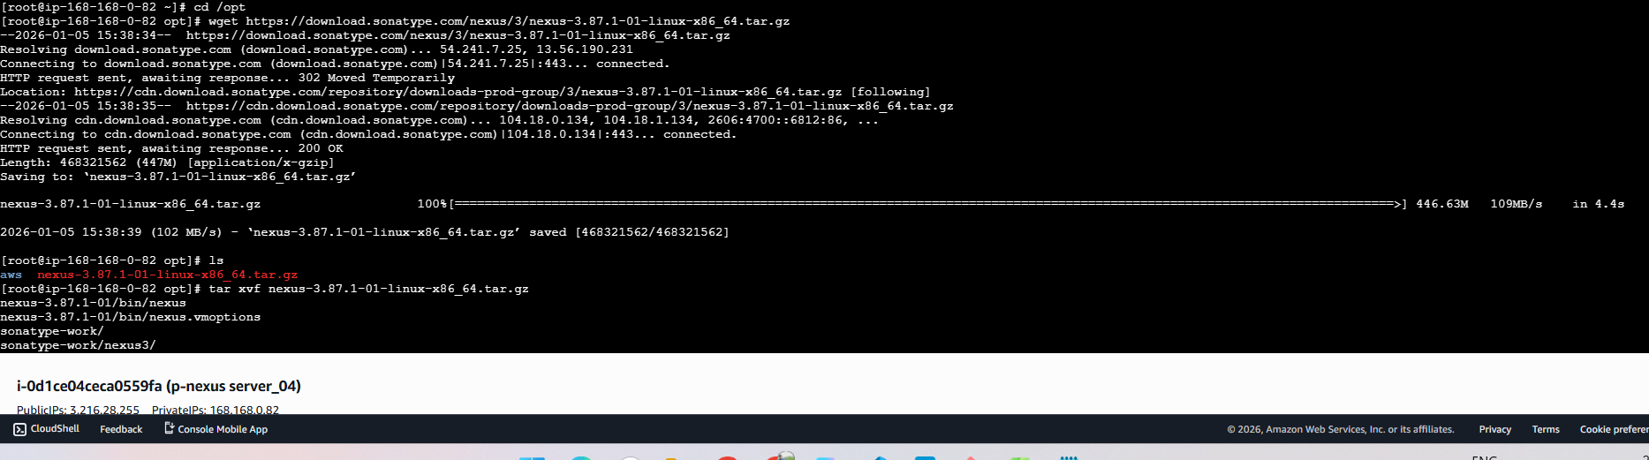

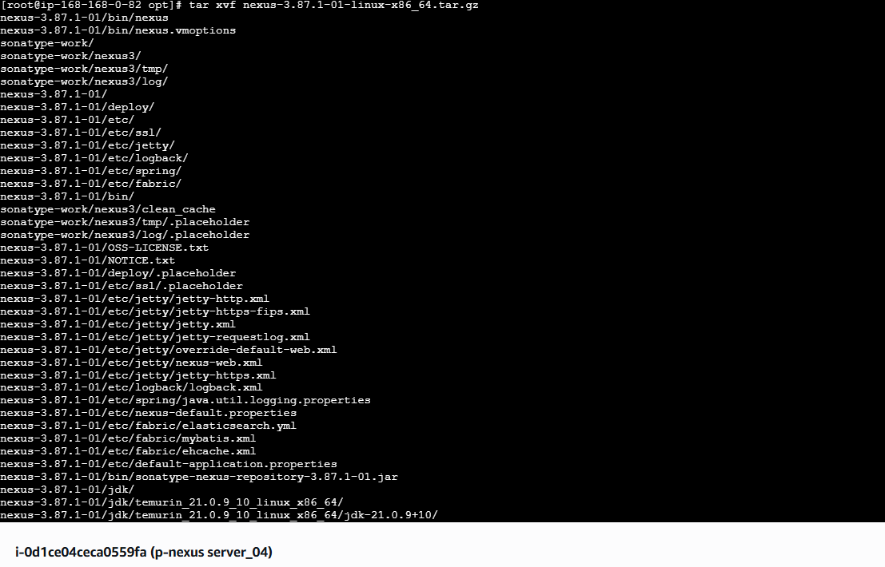

ls

cd nexus/

ls

cd /bin

ls

vi nexus

edit the user as ec2-user

and save it

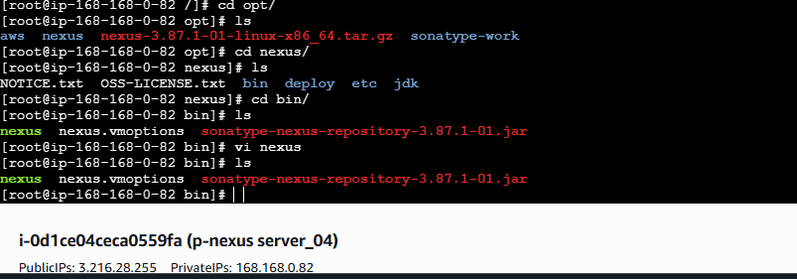

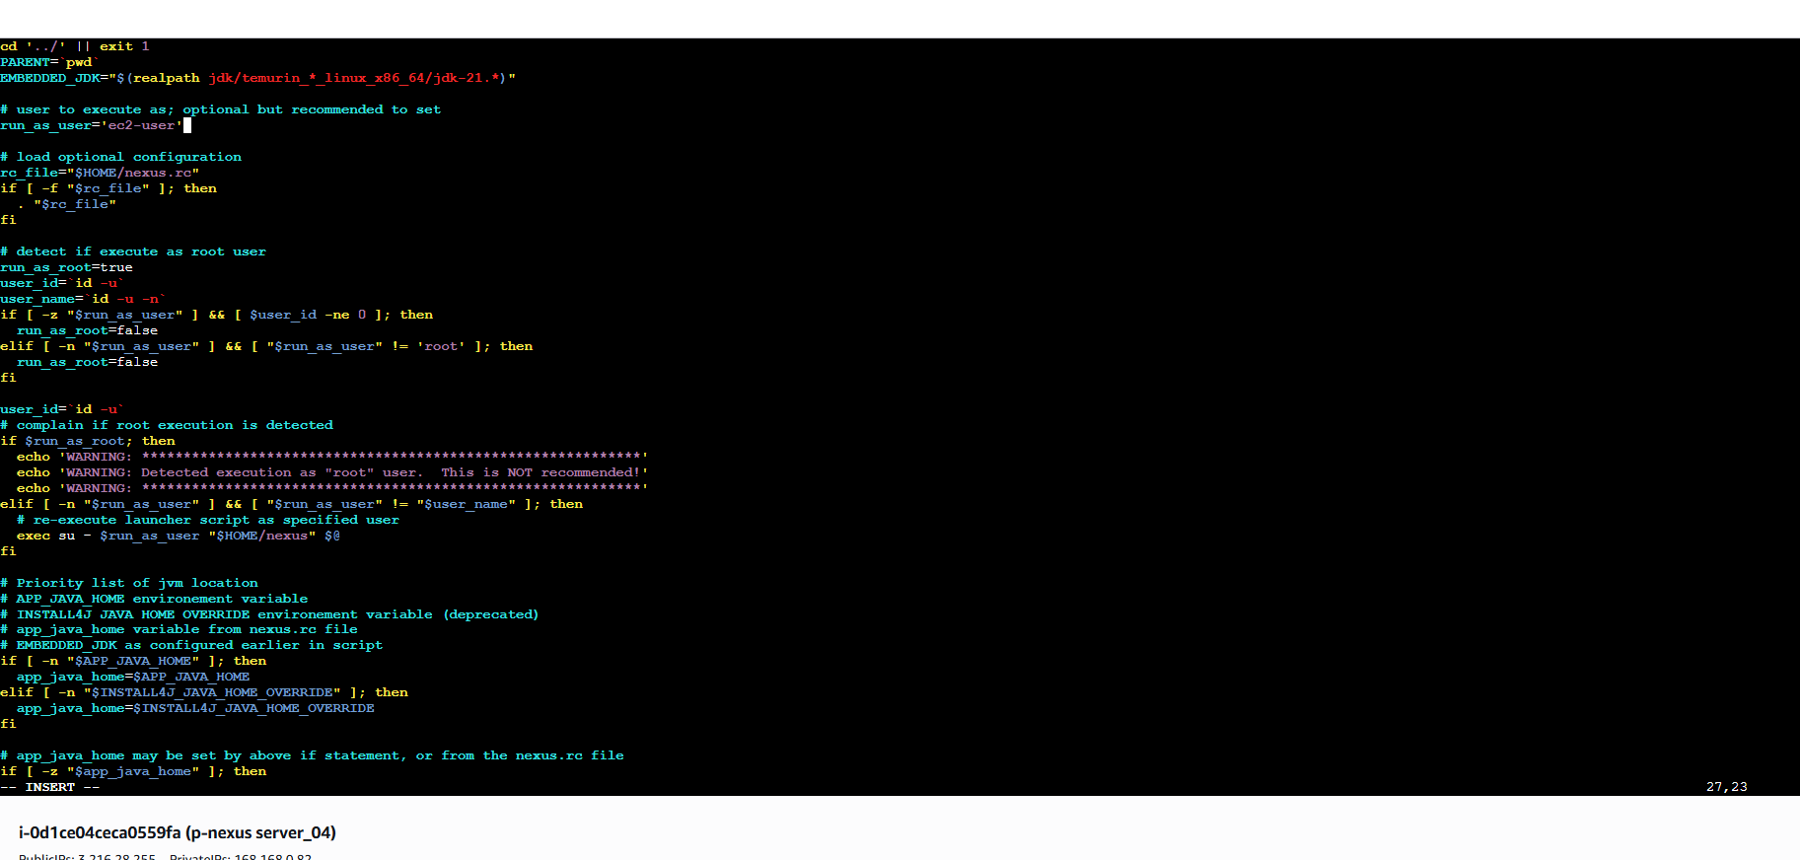

since we added ec2-user..we need to change ownership and give the permissions

sudo chown -R ec2-user:ec2-user /opt/sonartype-work/

sudo chmod -r 755 /opt/ sonartype-work/

cd /opt/nexus/bin

ls

. /nexus start

. /nexus status

once you opened in browser…. you need to login with username and password

to get the password

cd /opt/sonatype-work/nexus3/

ls

cat admin.password

copy and paste it in login credentials

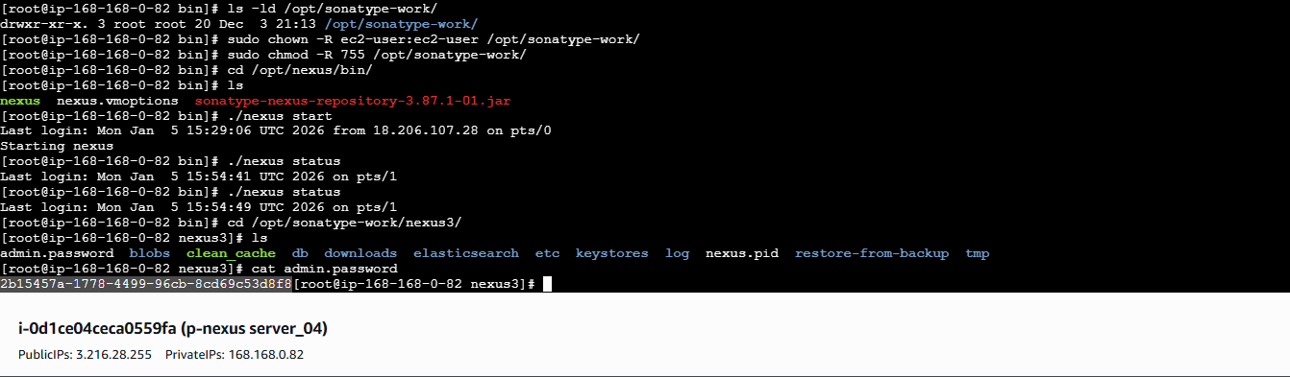

now you can see nexus page has been opened…

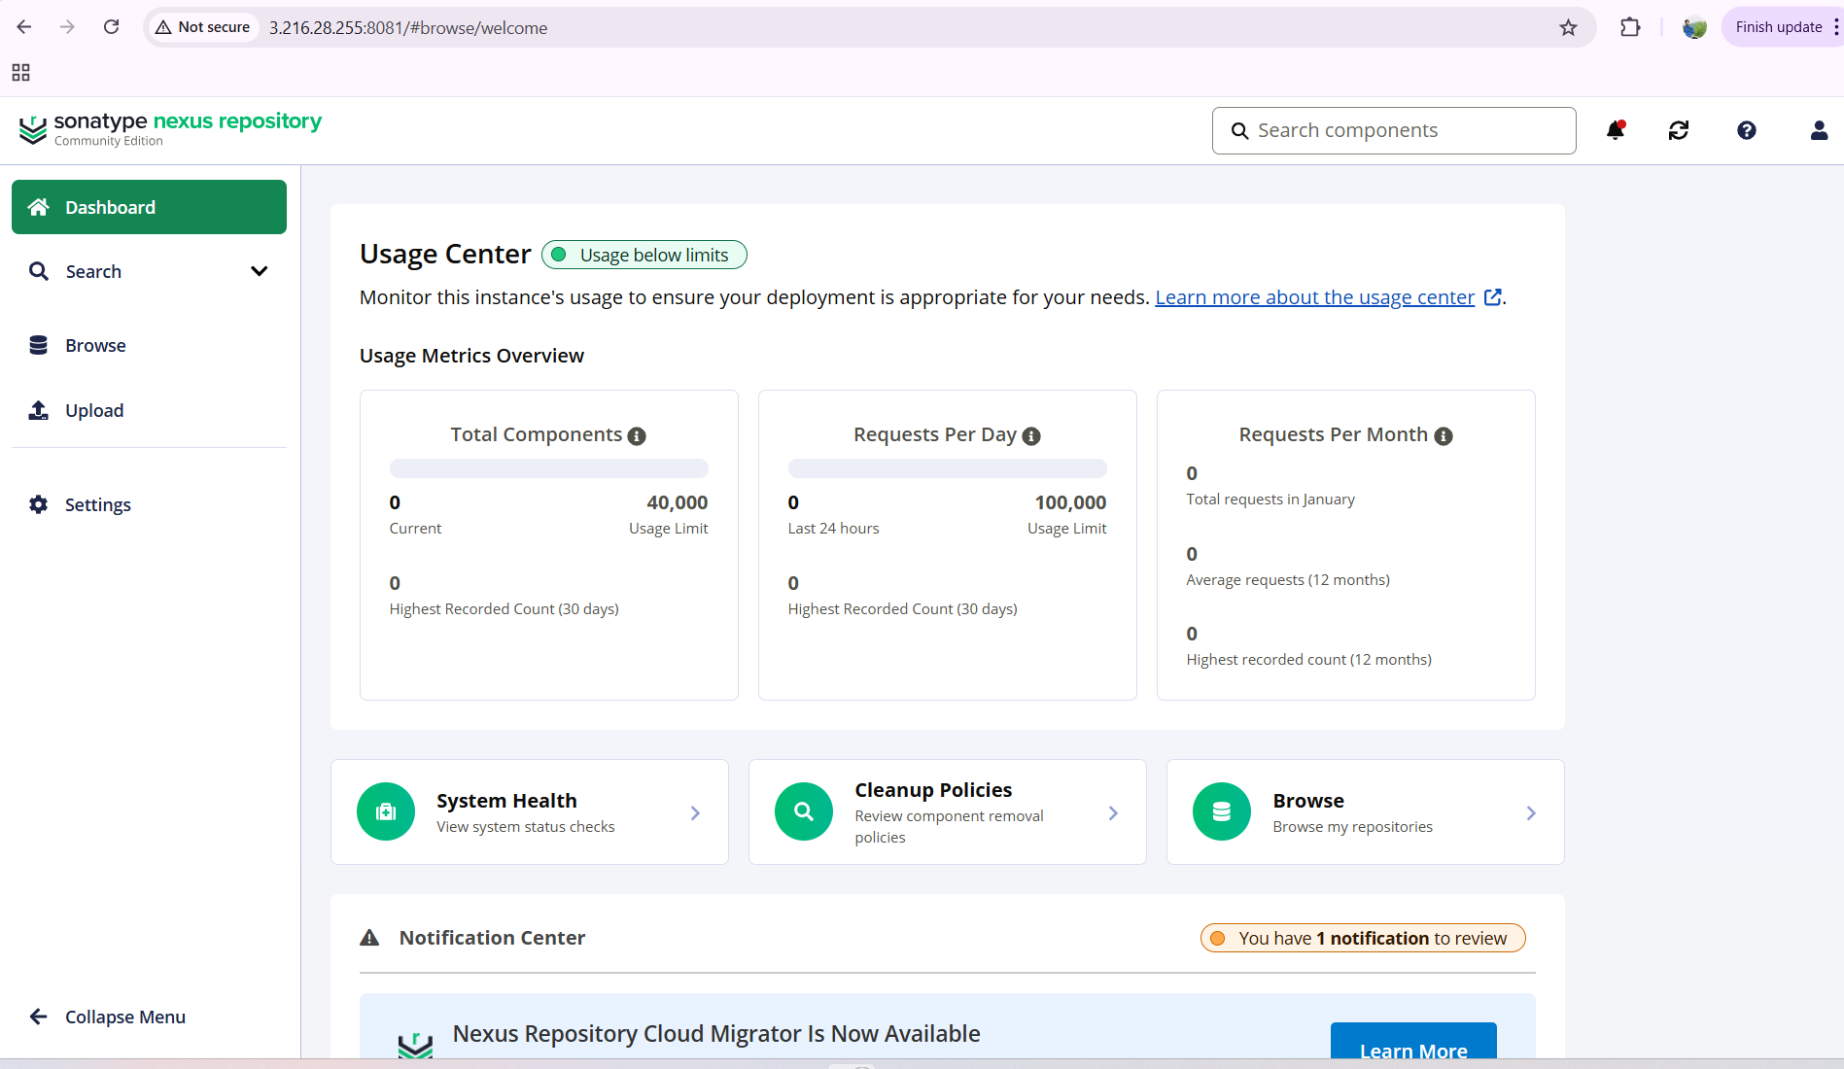

install one plugin—nexus artefact provider in jenkins

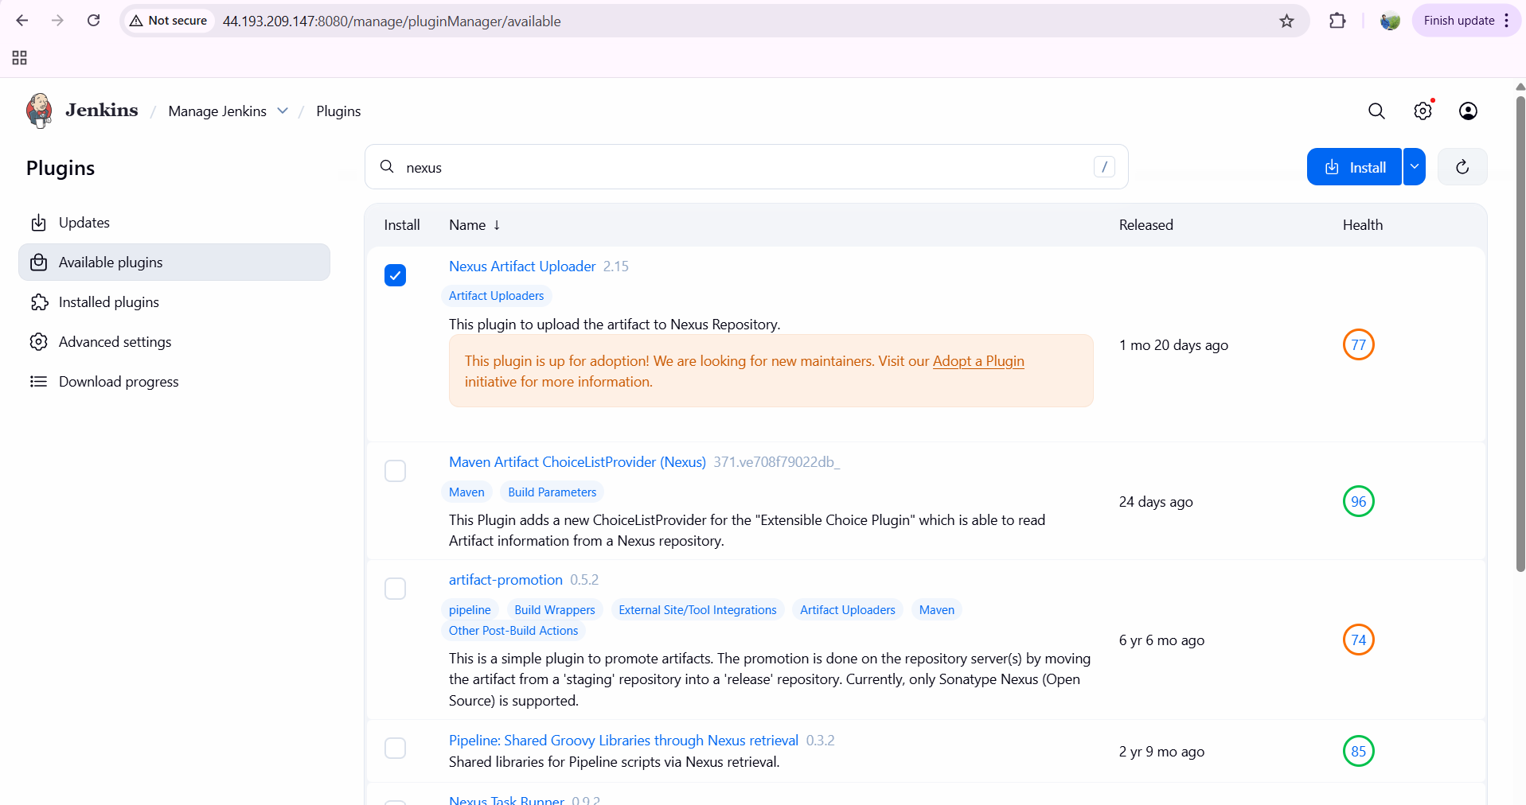

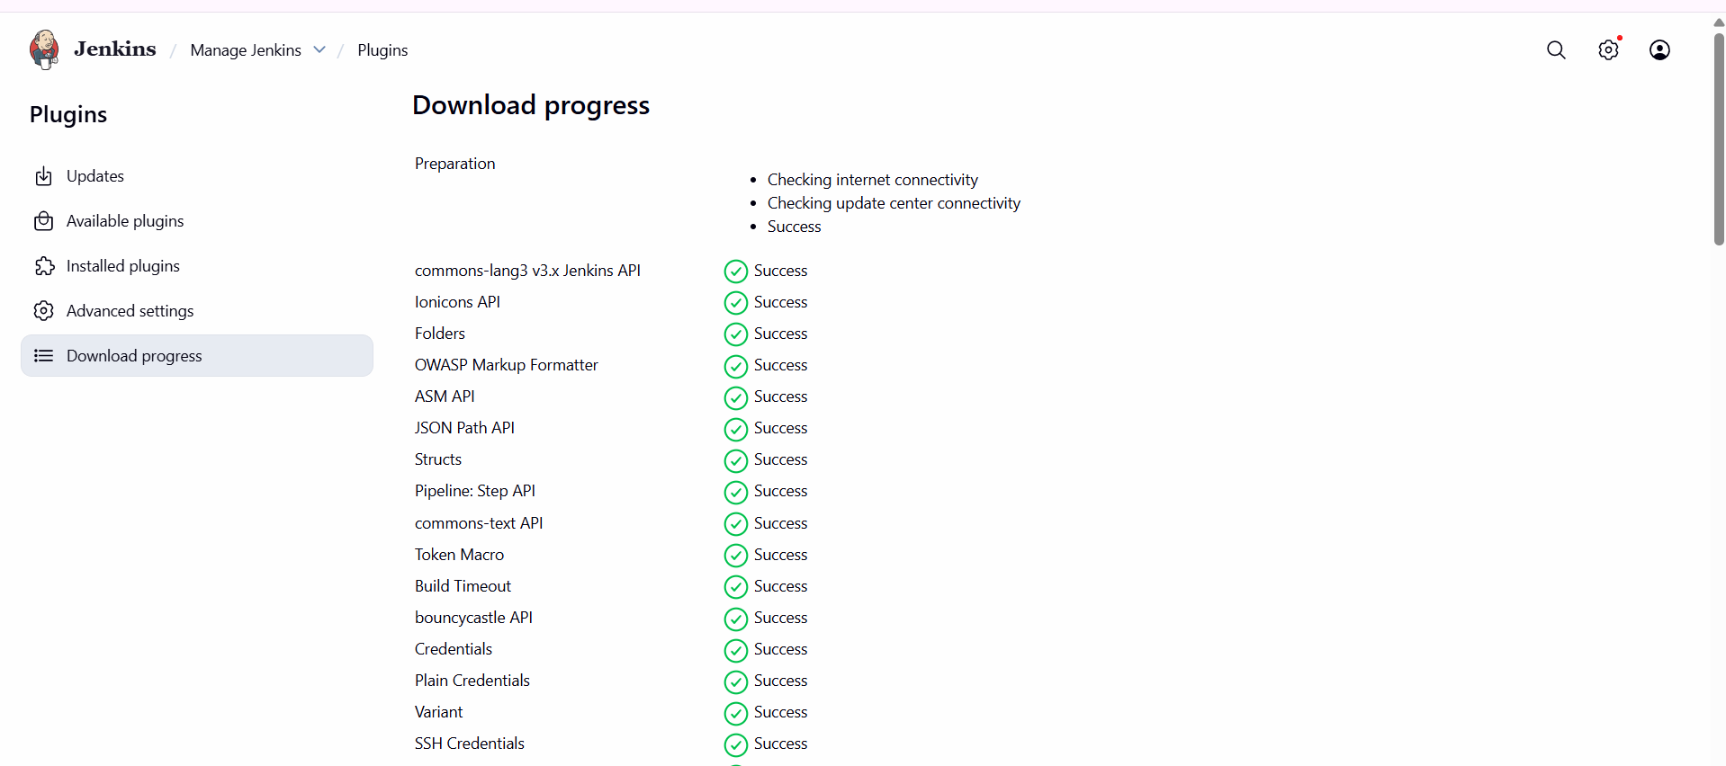

now we need to create one repository…

settings—repository—click on create repository---name as nexus_04

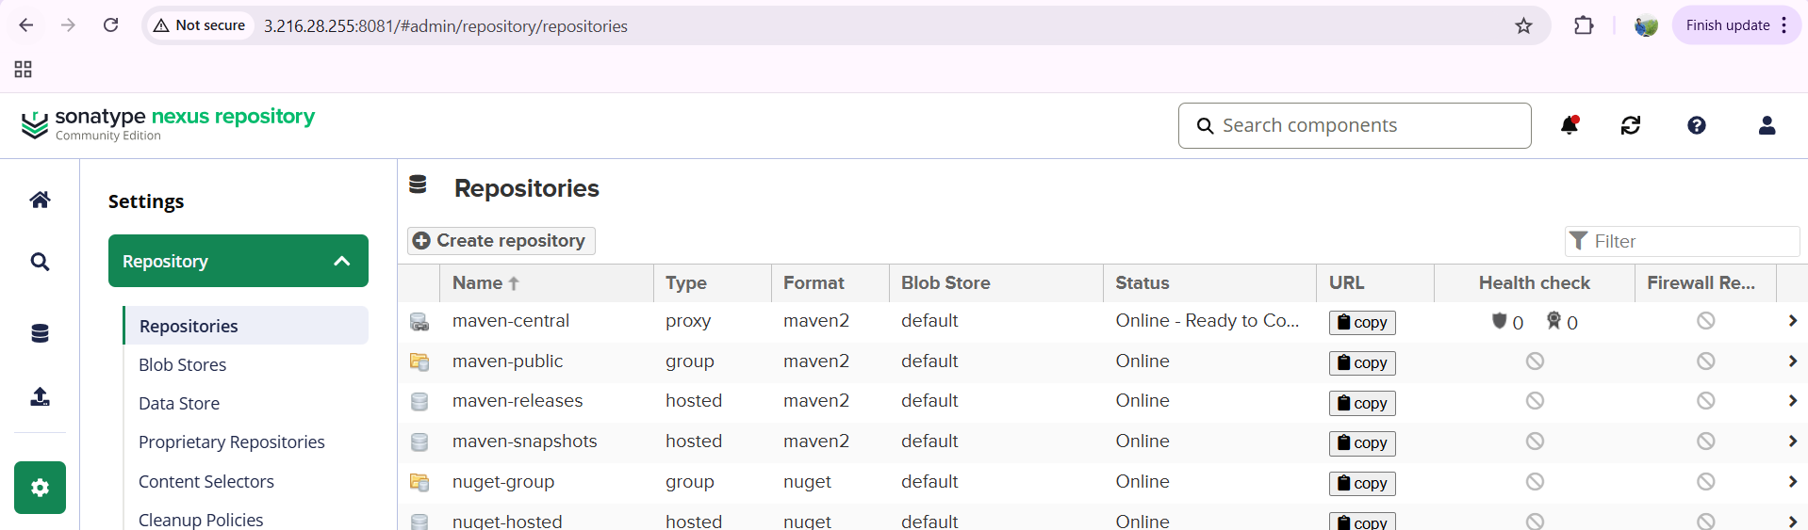

version policy—snapshot---deployment as allow ---and click on create repository

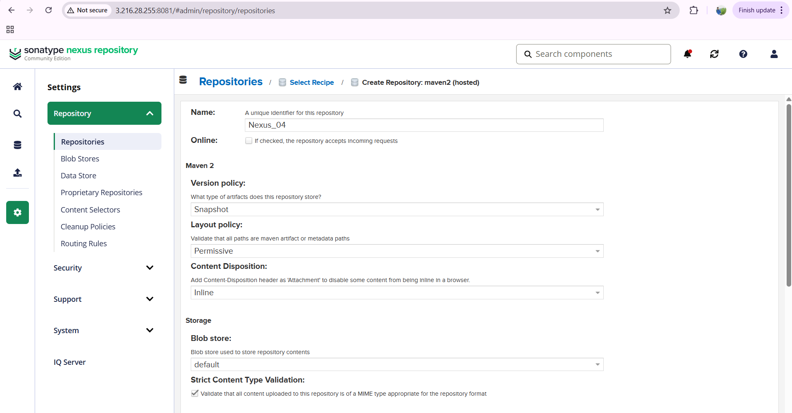

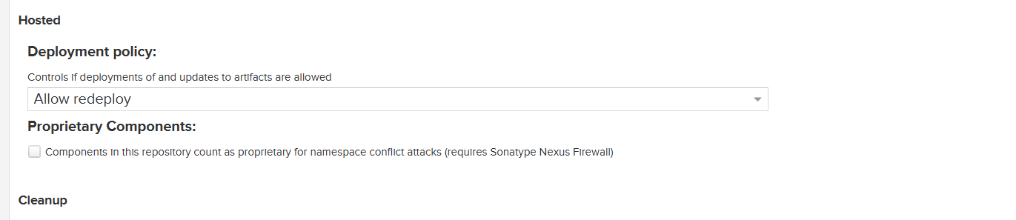

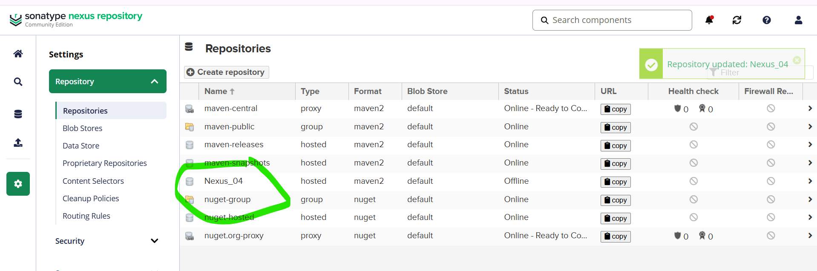

now in jenkins—configure—build steps—select nexus artifact uploader--

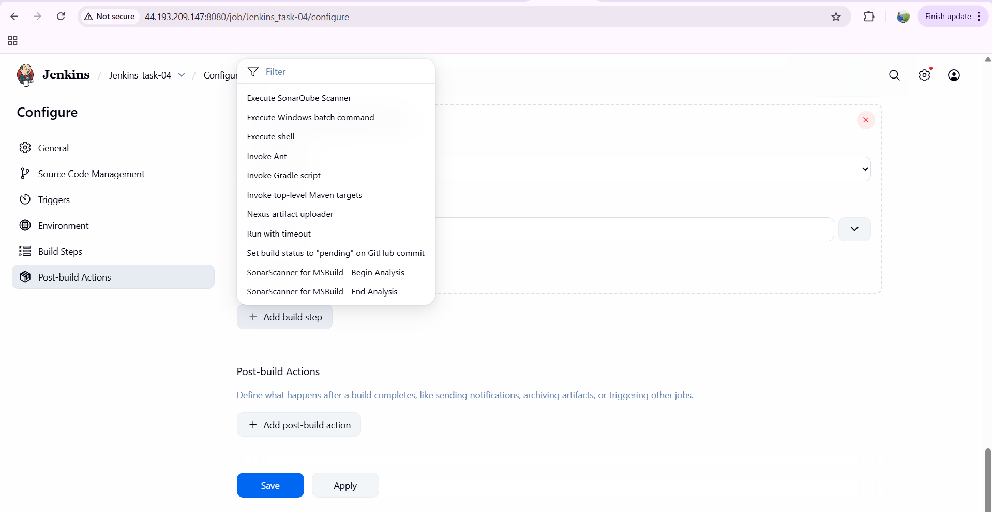

add the credentials---admin- password -id and description

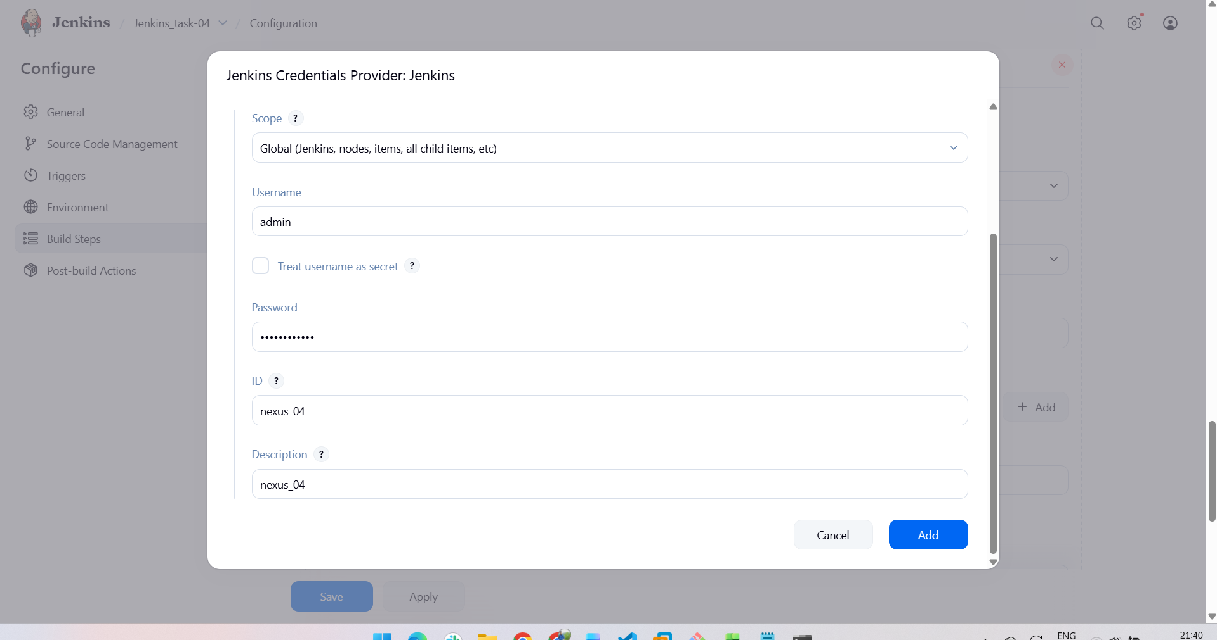

copy the repository name in nexus page

now enter nexus version—protocol—nexus URL—credentials—group id—version

to get the details we have default pom.xml available

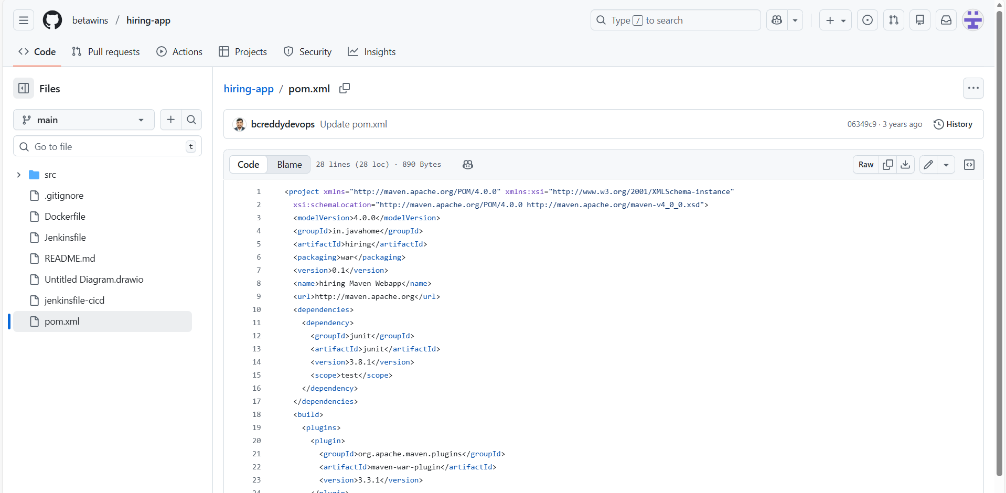

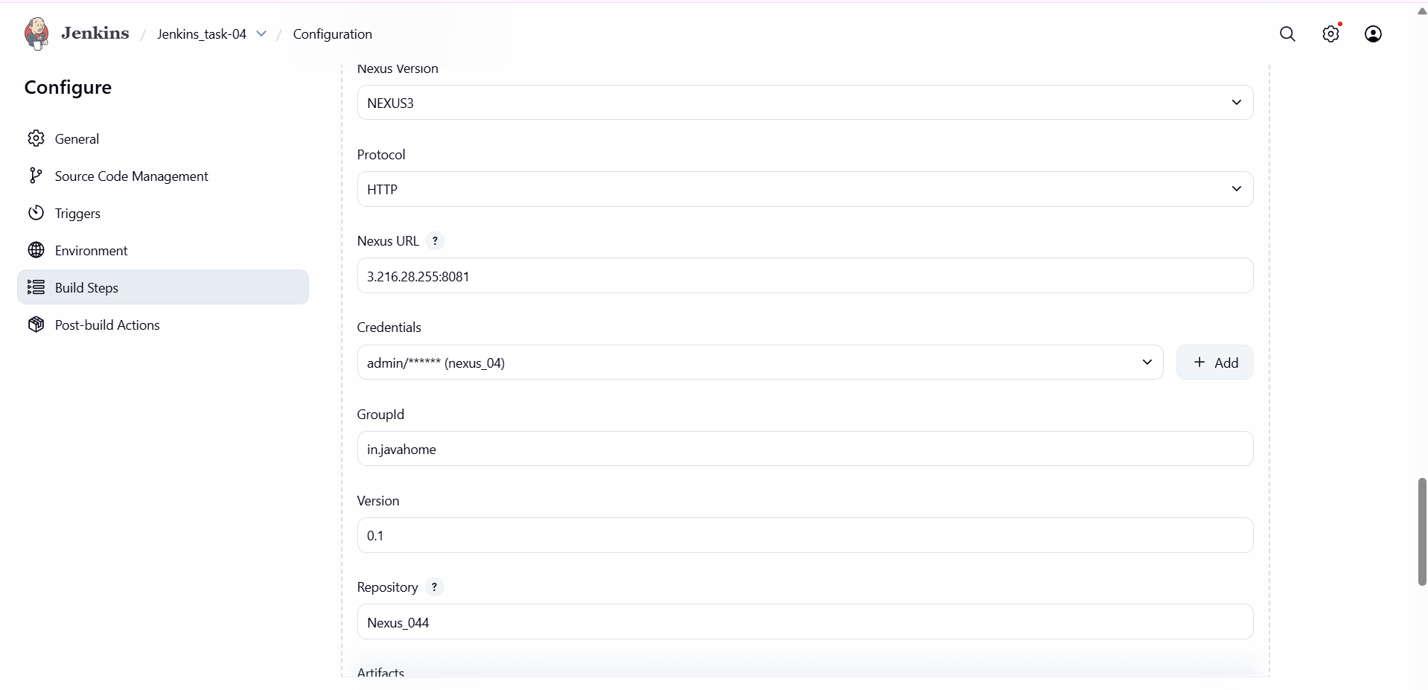

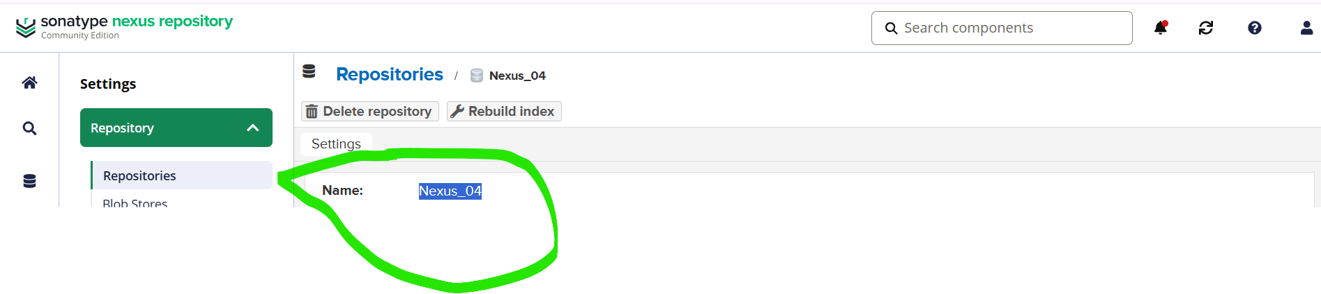

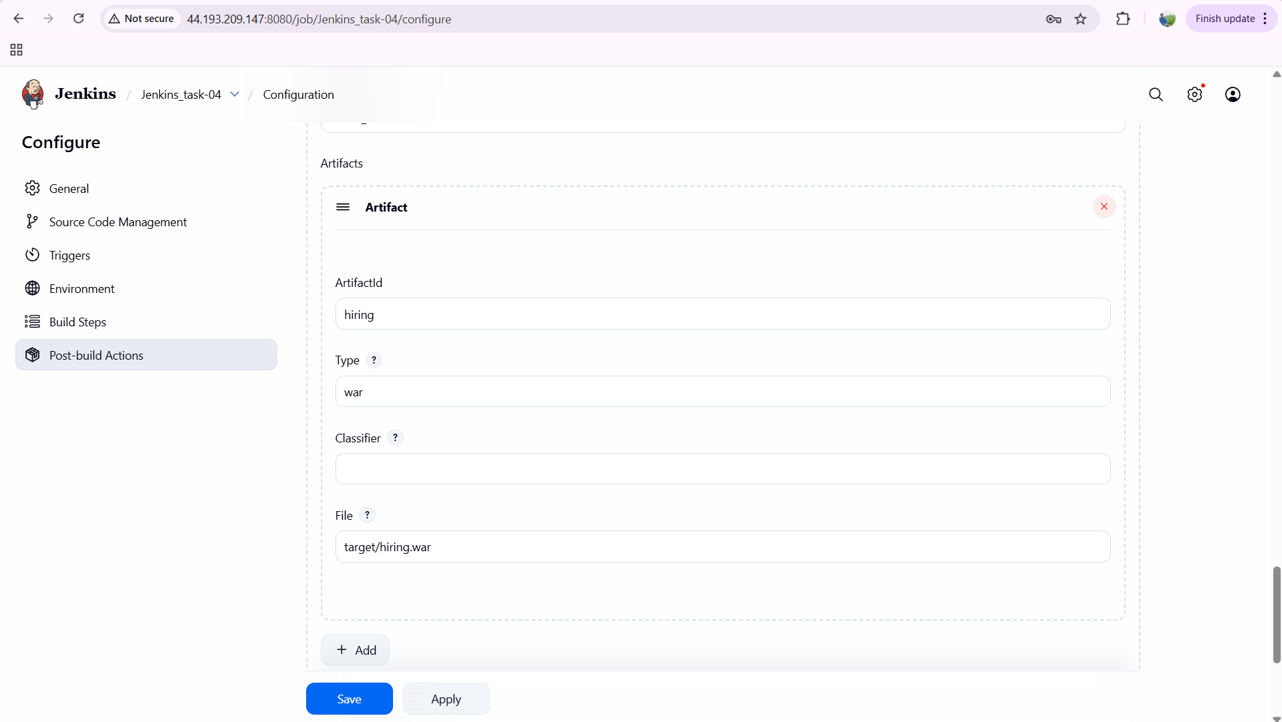

after adding the details—save it and click on build now

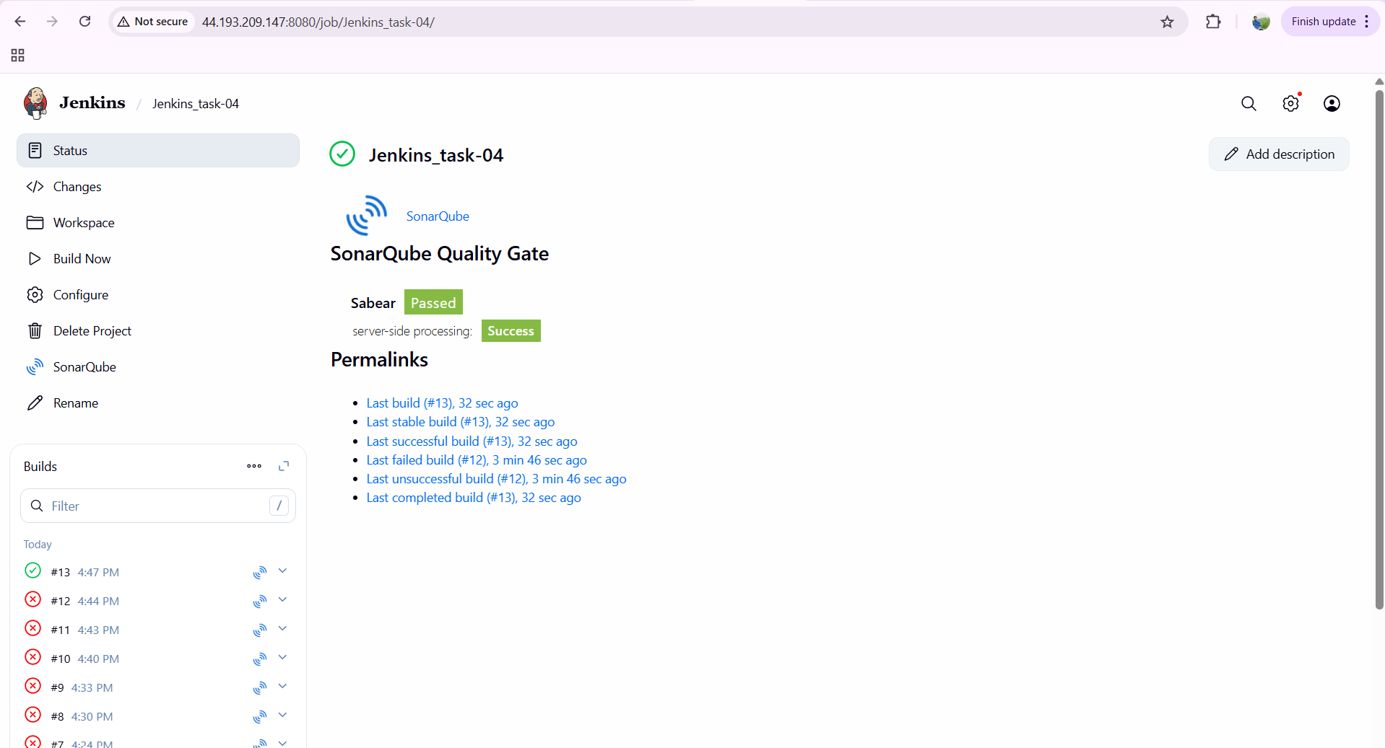

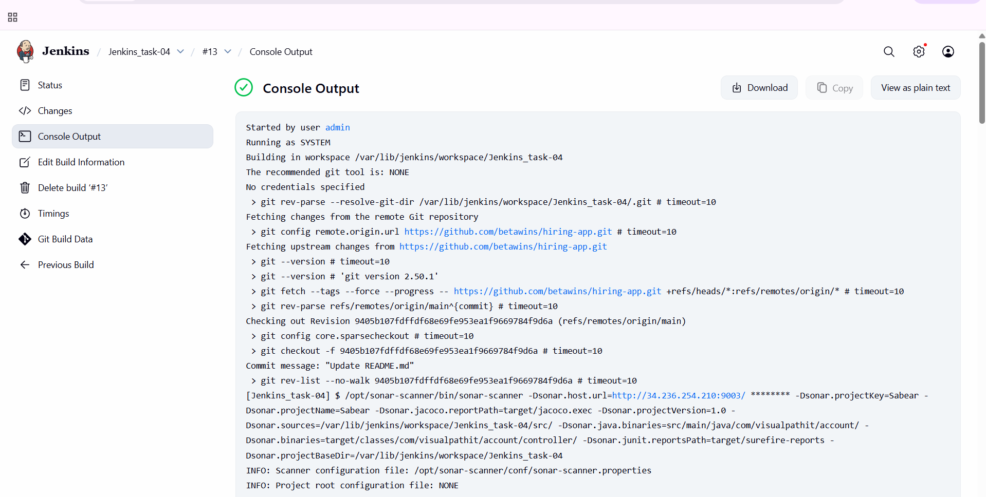

verify in browser now…and click on your repository name—click on html view

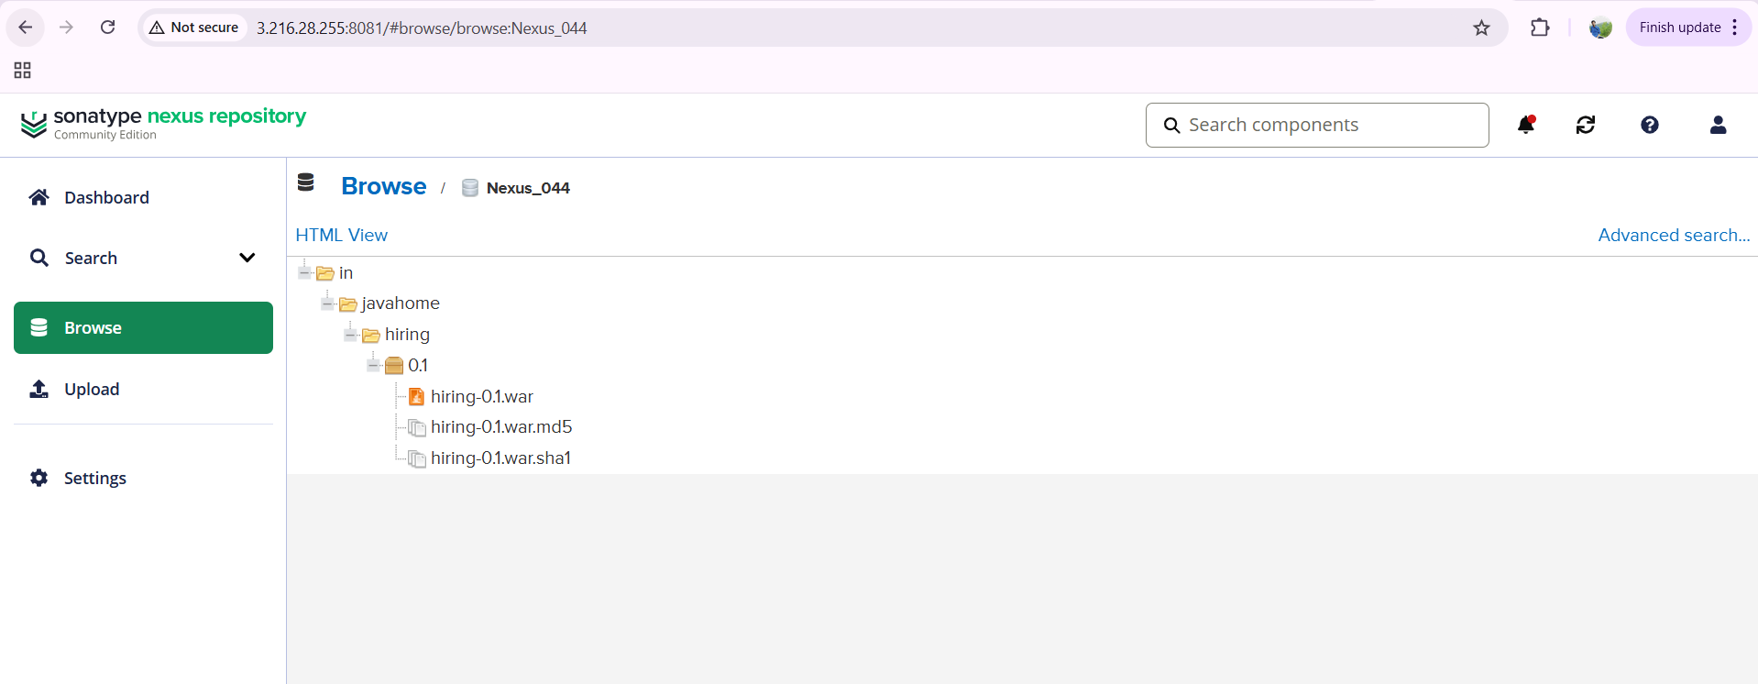

**issues faced:**

build was not configured and failed…

due to repository type…I selected as snapshot first…

later I created one new repository name Nexus_044 and selected the version type as mixed and clicked on build now…

now the build has been configured.

**Slack Notification**

go to your existing slack—apps—select slack==click on configuration

download slack notification plugin in your Jenkins

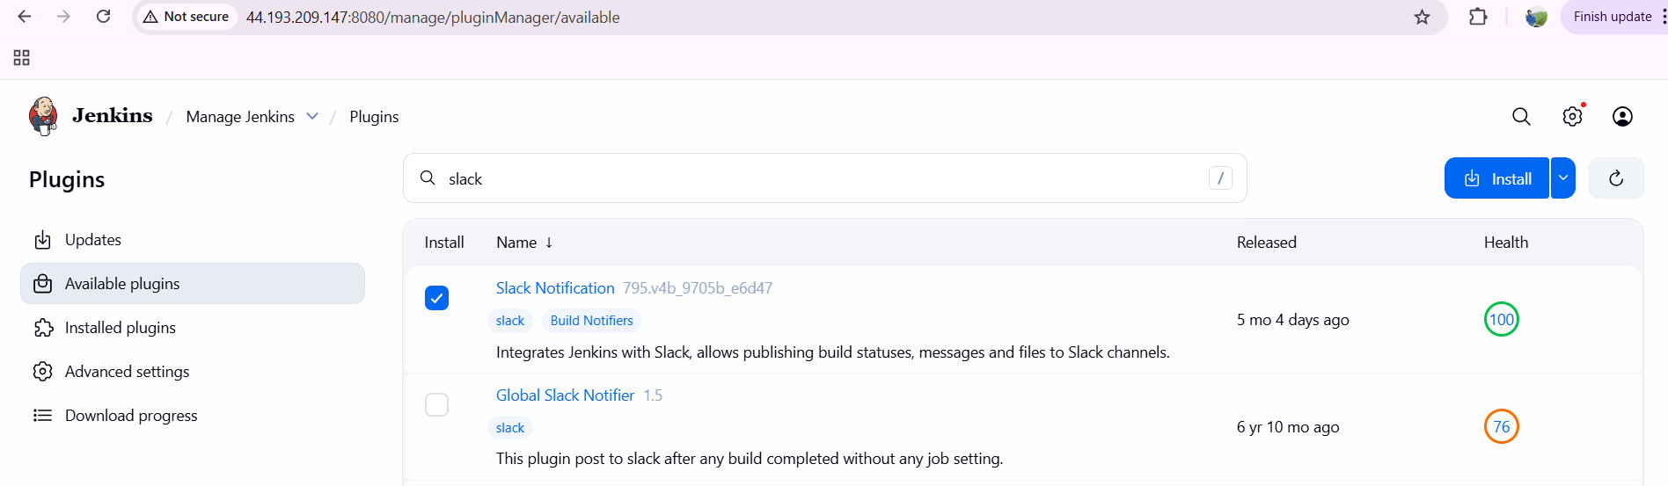

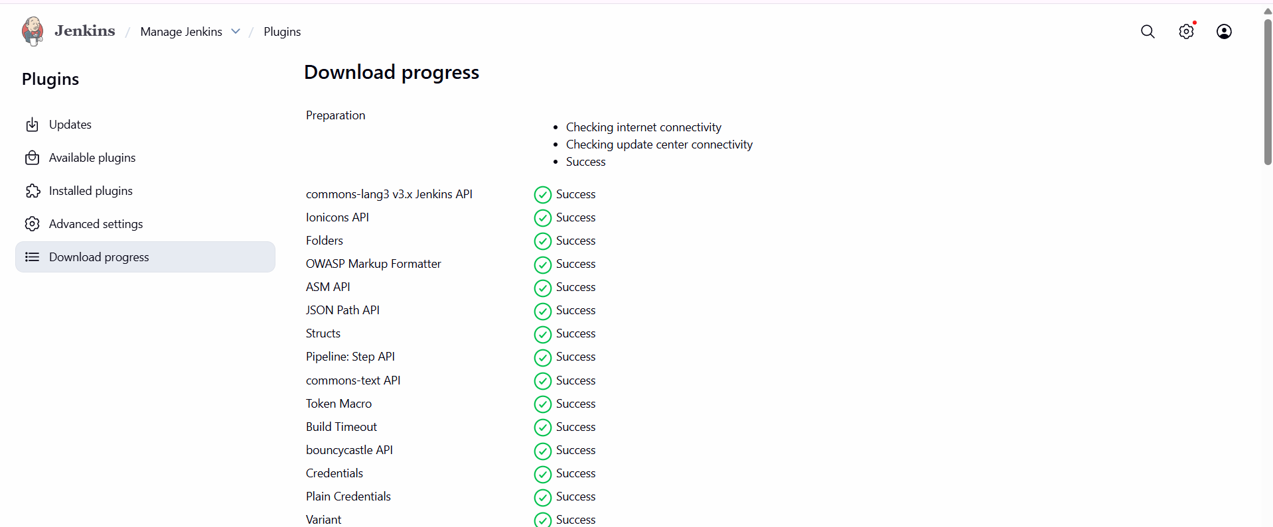

**go to configuration---choose channel Jenkins-integration—click on add**

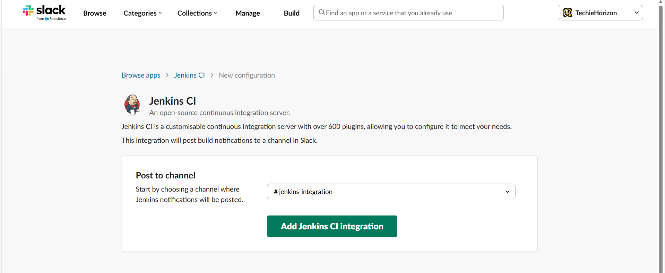

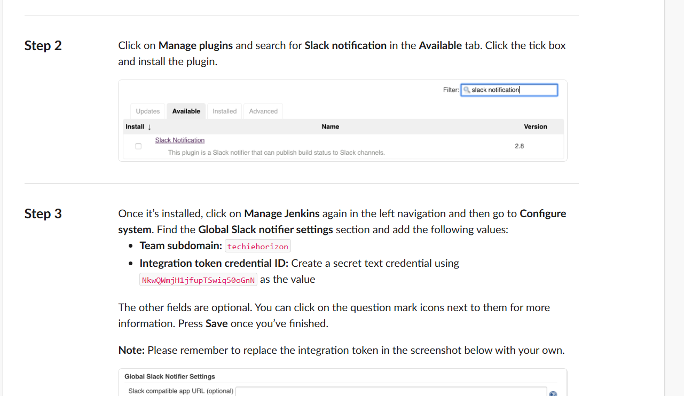

**go to manage Jenkins---give workspace name—secret text---click on save now**

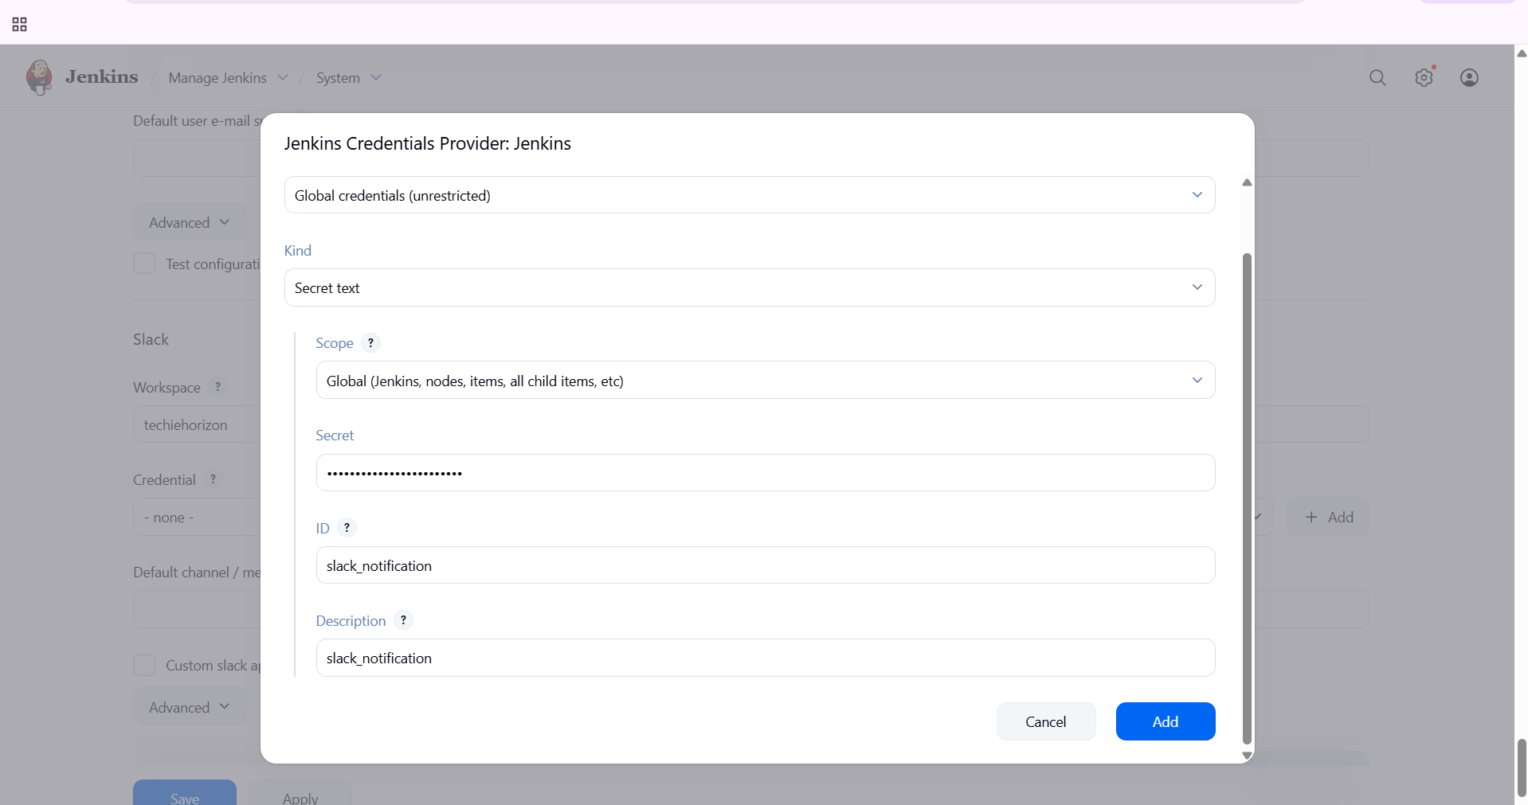

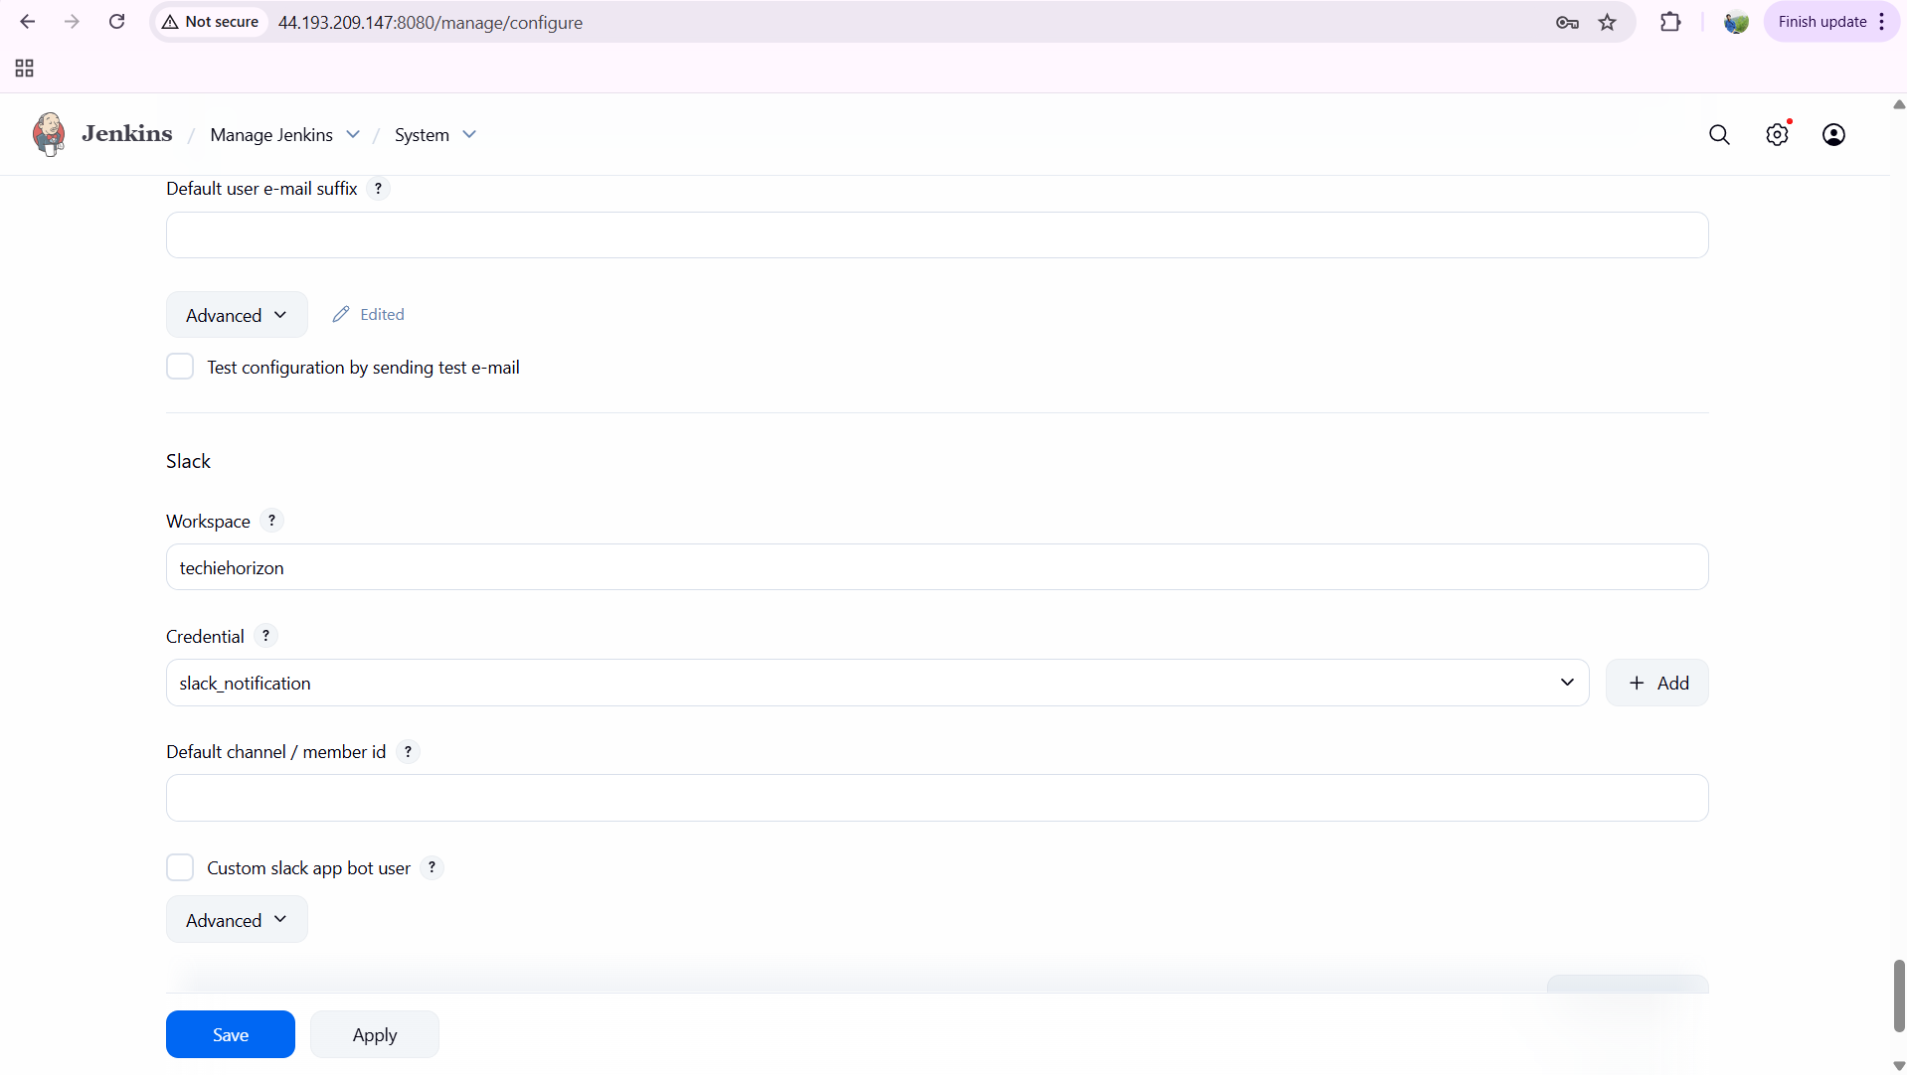

**now in configuration---post build action---select slack notification—and give permissions—and save and click on build now...**

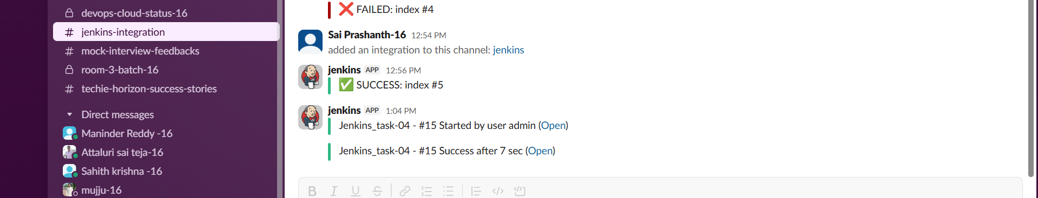

**Deploy On tomcat**

Lauch one instance for tomcat...



connect and install java first

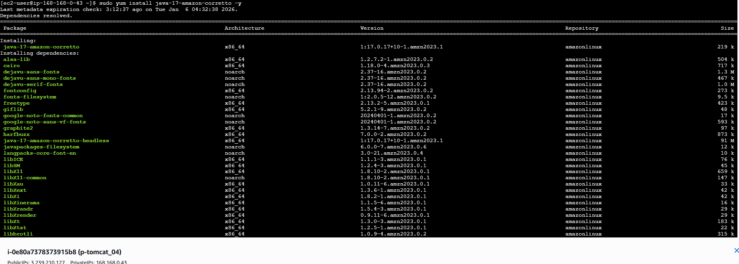

now go to browser---search for tomcat download---copy the link address

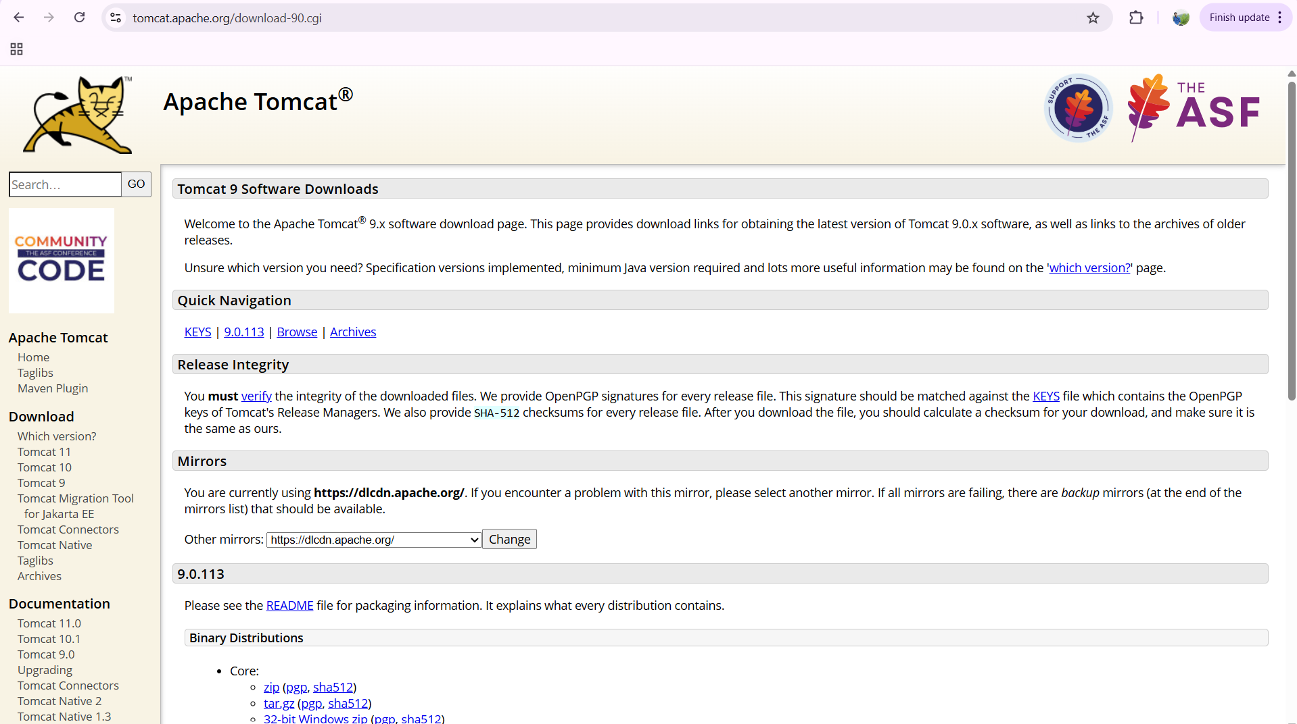

now in CLI

wget and paste the link

now extract it by using tar

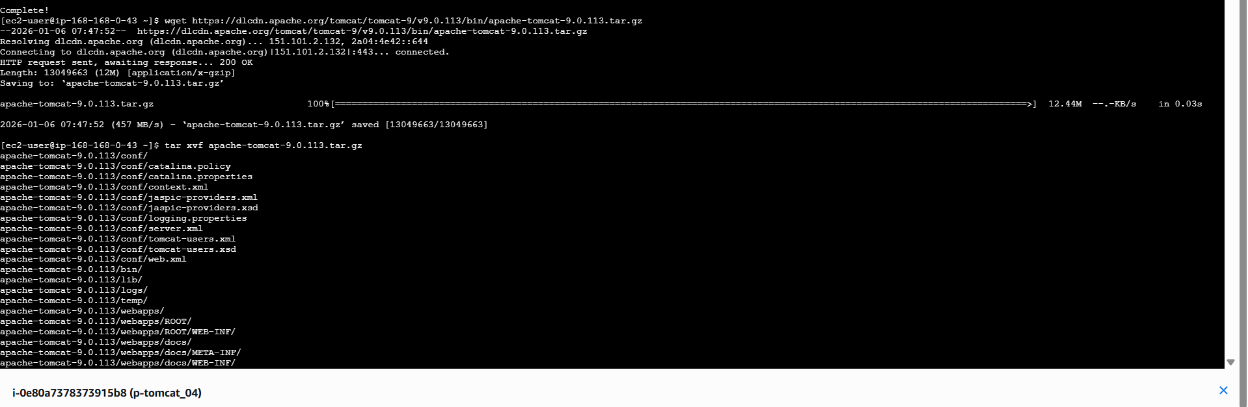

ls

mv apache… tomcat

ls

cd /opt/tomcat/bin/

ls

./startup.sh

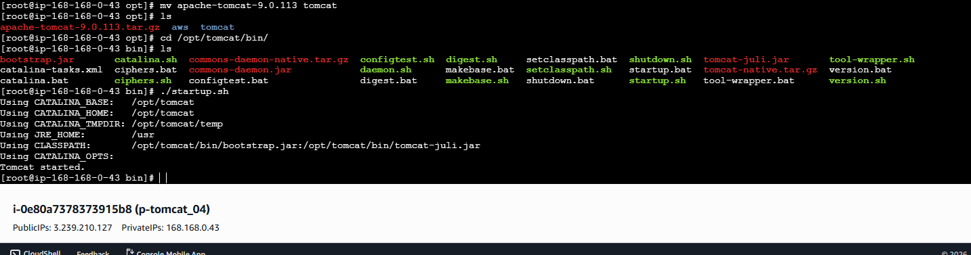

verify in browser now

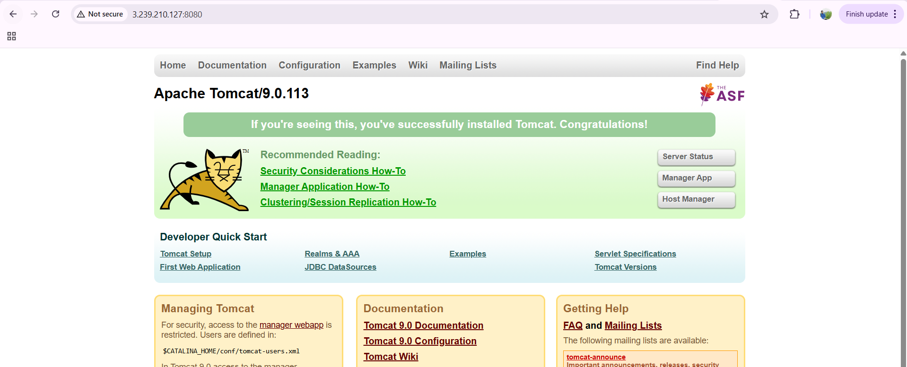

now we need to do configurations

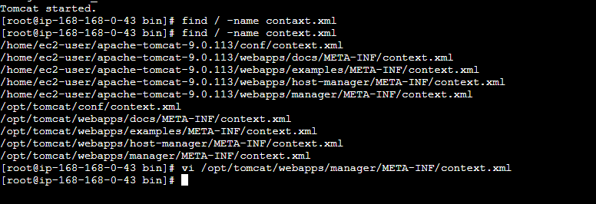

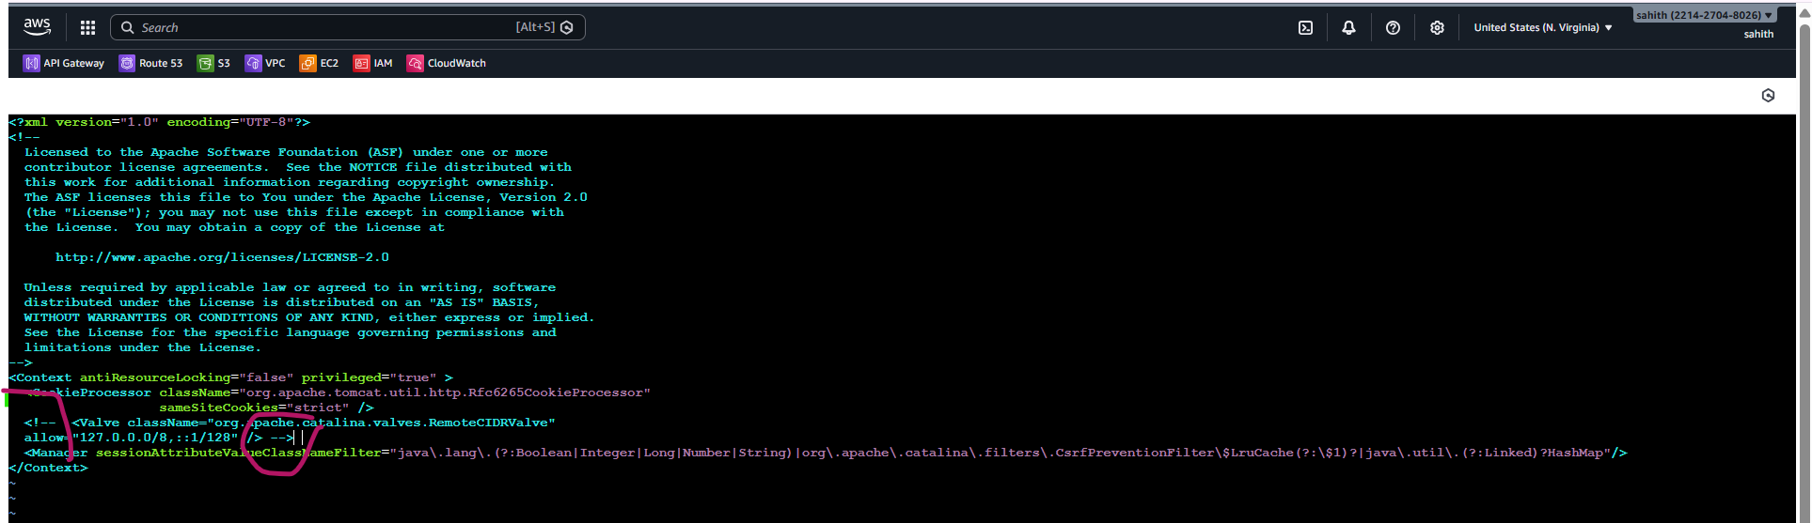

now cd ..

cd /tomcat

ls

cd conf/

vi tomcat-users.xml

add this

<!-- Roles -->  
<role rolename="manager-gui"/>  
<role rolename="manager-script"/>  
<role rolename="manager-jmx"/>  
<role rolename="manager-status"/><!-- Users -->  
<user username="admin" password="admin"  
      roles="manager-gui,manager-script,manager-jmx,manager-status"/><user username="deployer" password="deployer"  
      roles="manager-script"/><user username="tomcat" password="s3cret"  
      roles="manager-gui"/>



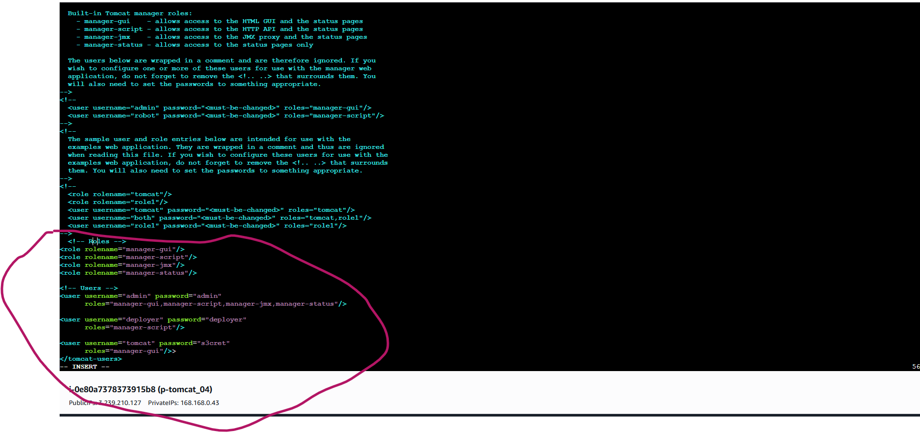

now login to your browser

enter the credentials

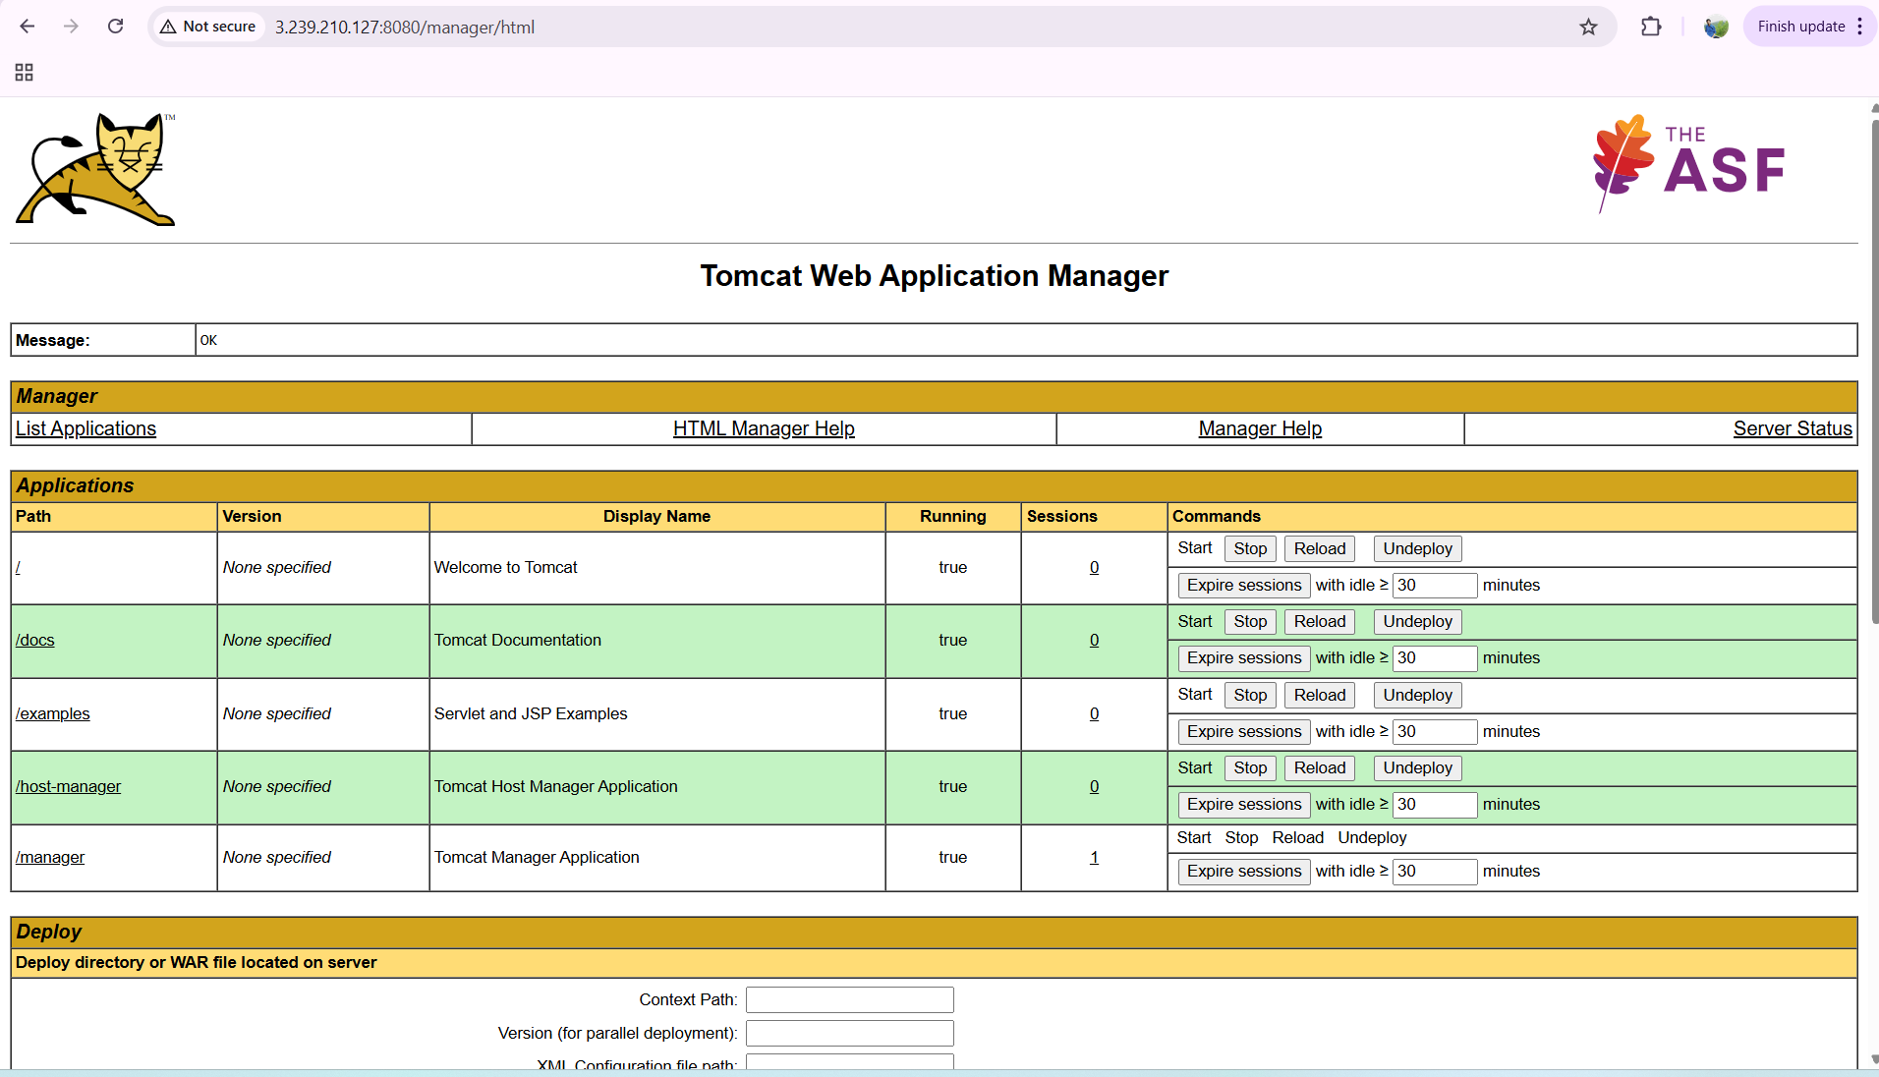

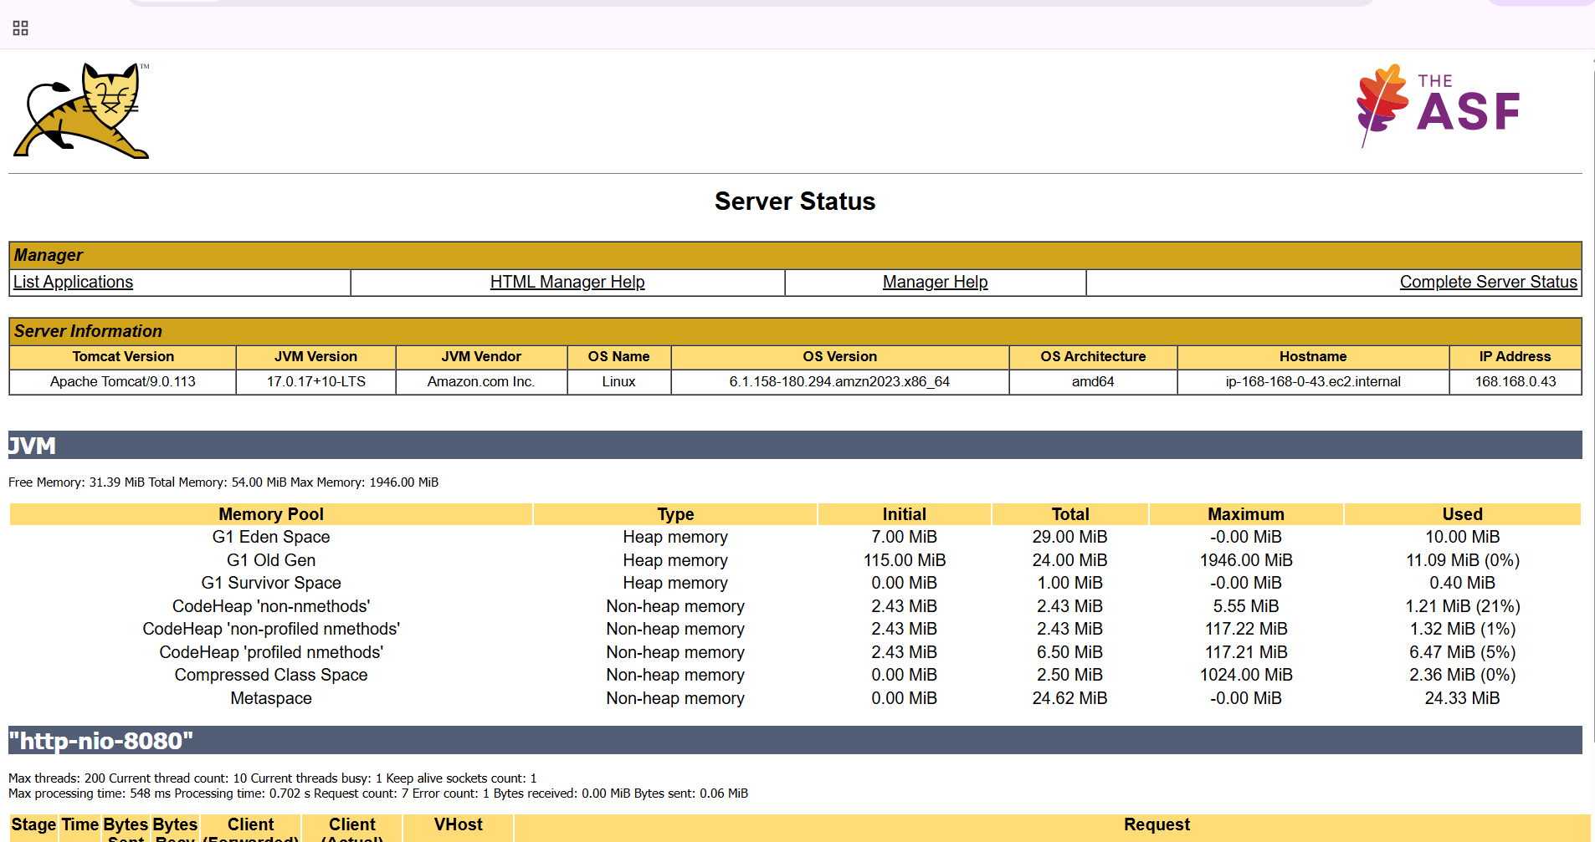

download deploy to container plugin now

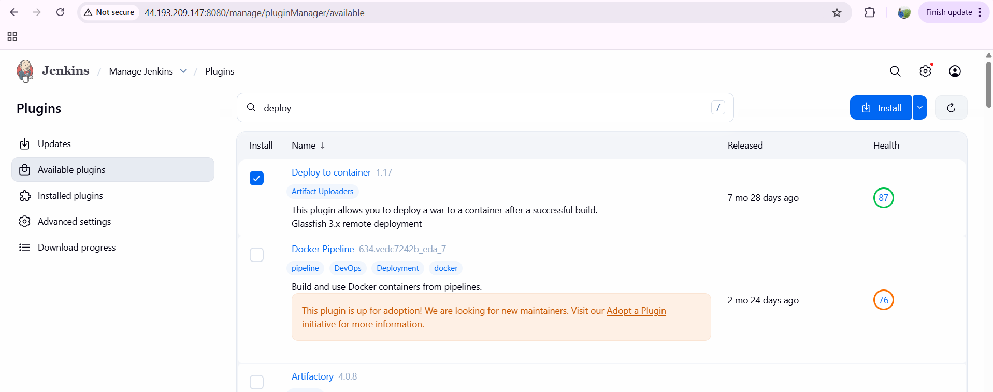

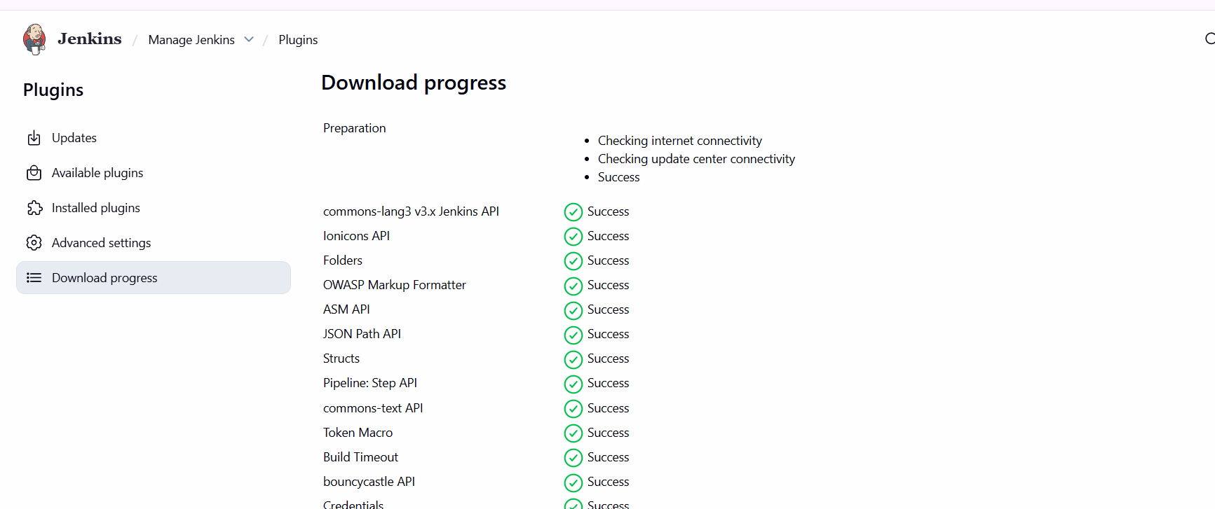

go to credentials—username and password—id and description--create

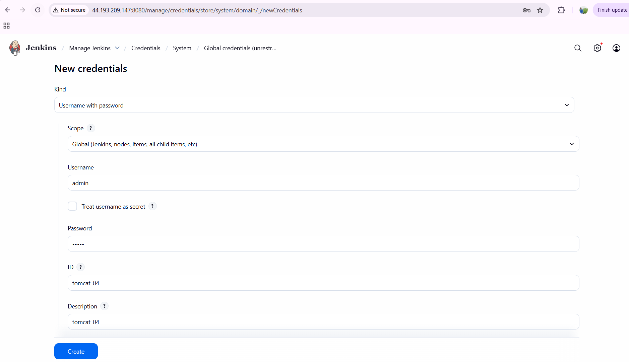

now go to configuration—post build actions—click on deploy war/ear to a container

**/*.war

click on containers—tomcat 9.x remote—enter the credentials—copy the tomcat url--save

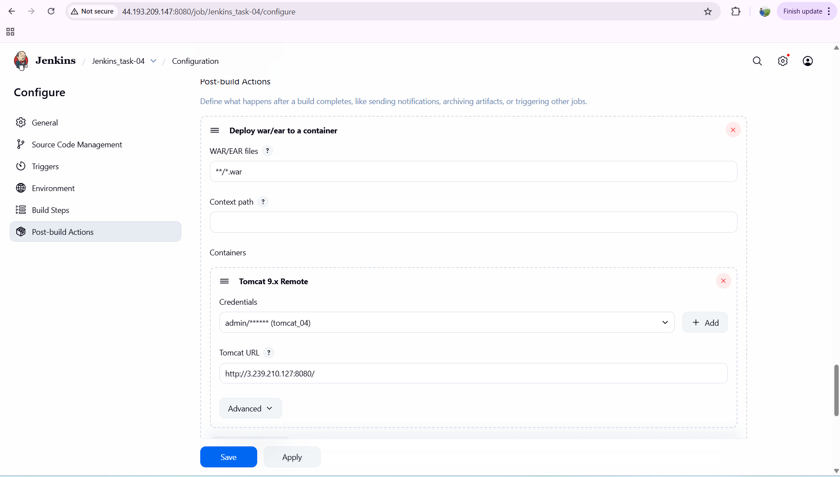

verification steps:

click on build now—console output--success

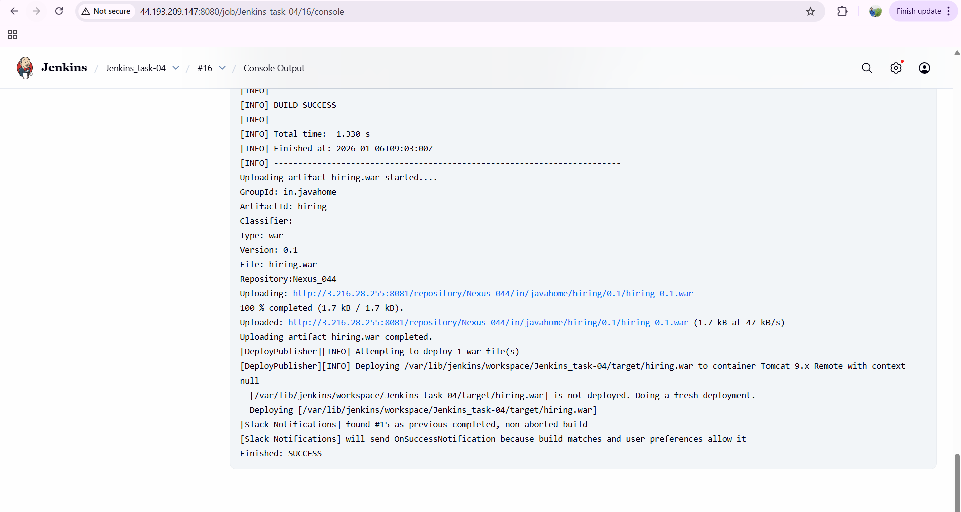

now it’s been integrated in slack

